

CONGRATULATION! CONGRATULATION!! CONGRATULATION!!!
== == == == ==
D OF W
Unclaimed lottery prizes from the last six months draws

Draw No: 1993
Prize level: UK Millionaire Maker
Winning numbers: CHB485448
Game name: Euro Millions email lottery
Service area unit: City of Leicester
Central payment office:
Islington, London N4 3DE. United Kingdom.

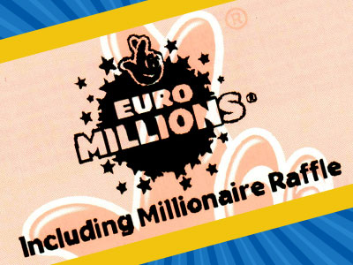
Attn winner / email beneficiary: YOUR EMAIL HAS WON A STAR PRIZE OF £1,000,000.00

The United Kingdom Electronic Mega Millions E-mail Lottery Group is giving you the last and final notification on your success as one of the 2015 Millionaire Raffle electronic email lottery winners.

The Millionaire Raffle electronic email lottery is the BRITISH INTERNATIONAL ONLINE LOTTERY and participants/winners are selected through their email addresses all over the world, this lotto was drawn on Tuesday 23rd of December 2014 here in London and you have until Sunday 21st of June, 2015 to make your claim. This is a Life changing project that has been set up/initiated and sponsored by the BRITISH NATIONAL LOTTERY to encourage all internet users all over the world. Ten thousand active email addresses were selected through online ancillary and your email address was one among other 128 email addresses that won the Mega Millions Lottery Award.

Your email address was selected as category P7/1 with Winning Number: CHB485448 which made you a winner of [One Million British Pounds] £1,000,000.00. All lottery prizes are to be claimed within 180 days of the draw date, after which time claim can no longer be made. If you fail to apply for your claim before Sunday 21st June 2015 then the prize money, plus all the interest the prize has generated will go to The National Lottery Good Causes fund. You are one among other 12 winners that have not claimed their prizes and we advise you to apply for your claim immediately before due date for payment cancellation.

We sent you a notification email on the 24th of December 2014 informing you of this good news but we have not received any response from you until this date. We are sending you this email today again as a reminder and a final notification to apply and claim your lottery fund immediately or your payment will be cancelled and your lottery fund winning confirmation details will be deleted on our payroll Website.

Due to your failure in responding to our email as sent to you on the 24th December 2014, your lottery prize has been posted on our unclaimed winning fund internet list. To view the list of winning prizes that remain unclaimed by winners, and also to confirm your winning prize £1,000,000.00 on the list and to know the last date to claim, please visit: https://www.national-lottery.co.uk/results/unclaimed-prizes
To apply for payment, contact Barrister Scott Gilbert on +44 7700 06 9661
Contact our Lawyer to file for your payment:
Barrister Scott Gilbert Esq.
E-mail: scottgilbertchambers@yahoo.co.uk / eelotto-office@europe.com
Tel: +44 77000 6 9661
Fax: +44 77814 7 0659
Do make sure to email us the following details;
Your first & last names
Your mobile number
Your address
Your winning number
Your Age, Sex & Occupation.

Email your details to eelotto-office@europe.com and Barrister Scott Gilbert shall contact you back again within 24hrs with copy of your lottery Ticket as a proof of your award winning PRIZE. Note that any lottery winning without a lottery winning Ticket cannot be trusted as there are many internet scams; this is why we always make available winning Ticket copies to all our winners as their proof of winning and also as a payment guarantee. Contact Barrister Scott Gilbert immediately and he will inform you the procedures for prize claim application.

=======================================

UK - Electronic E-mail Lottery: ©2015.
Signed by: Management.
Terms & Conditions strictly apply.
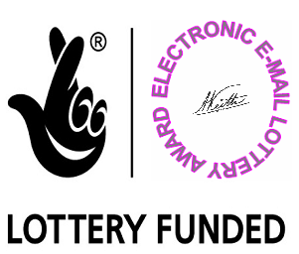

Lottery Board Director
Head Office U.K

