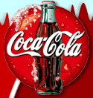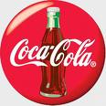


HEAD OFFICE LONDON UK:
From The Desk of the Promotions Manager
International Promotions Coca-Cola
124 Stockport Road, Long sight,
Manchester M60 2DB – United Kingdom Telephone: +44 7031748682.

(REF: GML-S343-KKT-8811 and BAT: 56T-DTH78 ZA99)
Web Site: www.mycokerewards.com

The Coca Cola Company Plc Official Yearly Prize Award Winners Notification.

Dear Guaranteed Award Winner,
This is to inform you that you have won the total sum of ₤2,950.000.00 (Two Million, Nine Hundred And Fifty Pounds) for this first quarter 2014 International E-mail Draw which was organized and Sponsored by the Coca-Cola Company Promotions Department (CCPD).

Your email address is among the winners in a random World Wide Web computerized draw system, extracted from over a million companies and individual email address of the people that are active online. Six people are selected yearly to benefit from this award and you are one of the Selected Winners.

Prize award must be claimed not later than 7 working days from the date of Draw Notification. Any Prize not claimed within this period will be confiscate and transfer to charity organizations.
Please you are advised to fill the form below and send it immediately to the claim manager for verification through our email below for prompt collection of your winning fund.
Claim manager Name Dr. Johnson Williams Huge.
: E-mail: dr.johnsonwilliamsadam14@gmail.com, cocacolauk22222@gmail.com
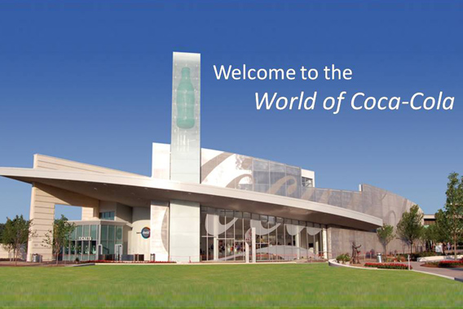
Fill The Form Below:
1. Full Names:……………
2. Residential Address:......
3. Mobile Number: ………
4. Occupation:……………
5. Sex:................................
6. Age:……………………
7. Country:……………….
8. City:……………………
9. Marital Status:………….
10. E-mails:………………..
11. Company Email And Address/Post:…………..
12. A Copy of Your International Passport/ID……
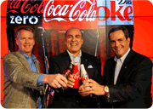
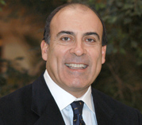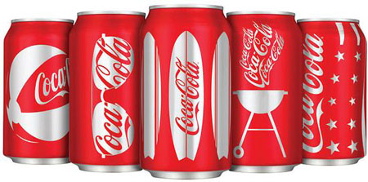
Sir. Muhtar Kent
Chairman of the Board and Chief Executive Officer The Coca-Cola Company Plc United Kingdom.
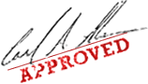
Accept my hearty congratulations once again! Yours faithfully, Mr. Muhtar Kent.
Note: we shall pay your claims through Bank or through diplomatic system Delivery, please contact our helpdesk urgently by phone or email for confirmation. Please quote your winning ballot number and ticket number for security reason.
Mrs. Theresa De Katz
Management

WE ARE OFFICIAL SPORNSOR OF 2014 FIFA WORLD CUP HELD IN BRAZEL AND WILL BE TILL 2022 IN QUARTER, COCA-COLA IS FOR EVERY BODY BOTH MAN, WOMAN, BOYS AND GIRLS FOR A HEALTHY LIVING.

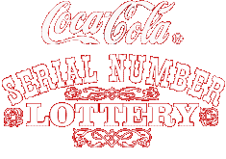
Prof. Alex Kingston and Dr.George Williams, Directors in Coca Cola Company Plc Online Promo England UK,
You are to keep all lotto information away from the general public especially your ticket number and ballot number. (This is important as a case of double claims will not be entertained).

From The Coca Cola Promotion Company Plc England UK. Kindly Contact Your Claims Agent Dr. Johnson Williams Huge through This Email: your ₤2,950.000.00 (Two Million, Nine Hundred And Fifty Pounds) Great British Pounds Now.
©"COPYRIGHT 2013 COCA-COLA ONLINE PROMOTION ALL RIGHT RESERVED
"* * * * * * D I S C L A I M E R * *
NOTE: This message is confidential and intended for the named addressee(s) only. If you are not the intended recipient, please contact the sender by E-Mail return and then delete this message from your system. You should not copy or use it or disclose its contents to any other person. If any part of this message is illegible or if you suspect that the message may have been intercepted or amended, please contact the sender. We cannot accept any responsibility for the accuracy or completeness of this message without further investigation.

