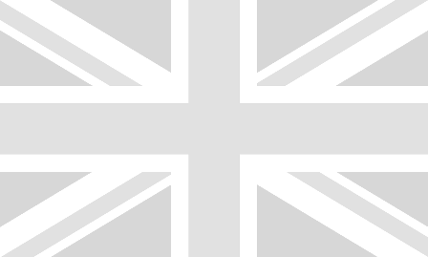

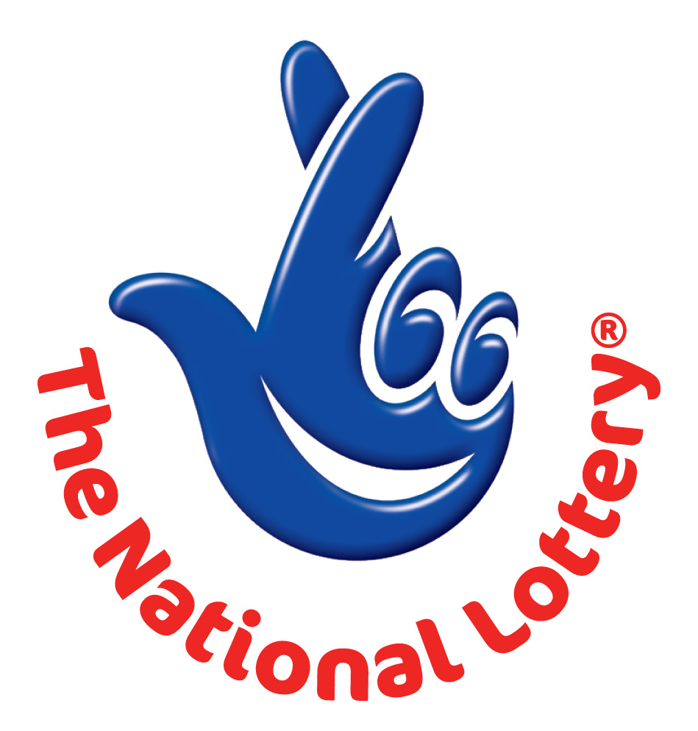

NATIONAL LOTTERY DRAW

UK-SOUTH AFRICA LOTTERY/ EMAIL DRAW 2014
UK Office No 47 Se1 7na – Balking London United Kingdom

WINNING NUNBERS: 1, 5,24,34,41 Bonus 10

Attn: Winner,

We happily announce to you the draw of UK/South Africa National Lottery, the UK/South Africa online Sweepstakes International program held for the year 2014.

You have won GBP₤1, 000,000.00 (One Million British Pounds Sterling Only) from UK/South Africa lottery draw 2014. Your Email ID was one of the selected emails all over the World Wide Web sites in the online lottery draw in which your email emerged as a winning email with the lucky winning numbers above. Please note that your lucky winning numbers falls within our Afro booklet representative office in Africa as indicated in our database here. In view of this, your GBP₤1,000,000.00 (One Million British Pounds Sterling Only) would be released to you by our nominated paying bank, First National Bank South Africa (FNB).

In order to process your winning for transfer, you are advice to contact our African judiciary agent with the details below for your payment.
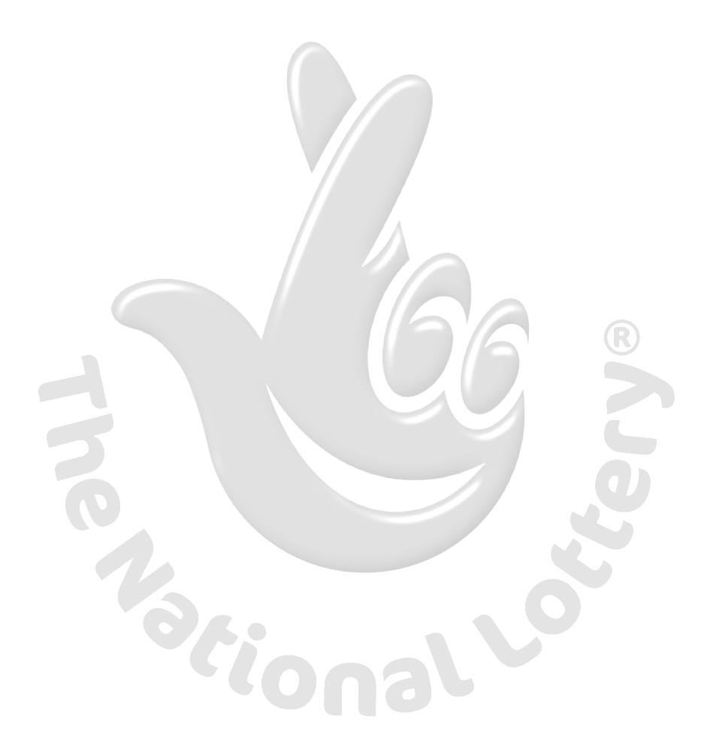
Name: Mr. Garret Adams B.
Email: garretoffice2@gmail.com
Alternative:garretoffice1@gmail.com
Tel: +27 747659857.
You are advised to send the following information to your Claim Agent to facilitate the release of your fund to you.

1. Full Names:
2. Country:
3. Contact Address:
4. Telephone Number:
5. Fax Number:
6. My Date of birth:
7. Occupation:
8. Sex:
9. Marital Status:
10. Winning numbers:
11. Winning Email:

Congratulations!! Once again.
Yours sincerely,
Regan Matt.

