


File Code #: ATM5623/JHB/ZA
Postal: PO BOX 75100 Sandton Central 2146
Johannesburg /South Africa
Telephone: +27742357747.

Dear Beneficiary.

This is to notify you of your email enlistment as a beneficiary of a recent inheritance fund of ($3,000. 000.00) Three Million United States Dollars from Web industry award schemes to the online internet users

The web industry represents the interests of internet and computer user worldwide sponsored by the global industry, software companies, equipment providers and Internet companies.

Important Notes:

Microsoft Wallet allows various internet users clicking into many websites which gives you the enlisted beneficiary total sum $3,000.000.00 as referenced above to claim.

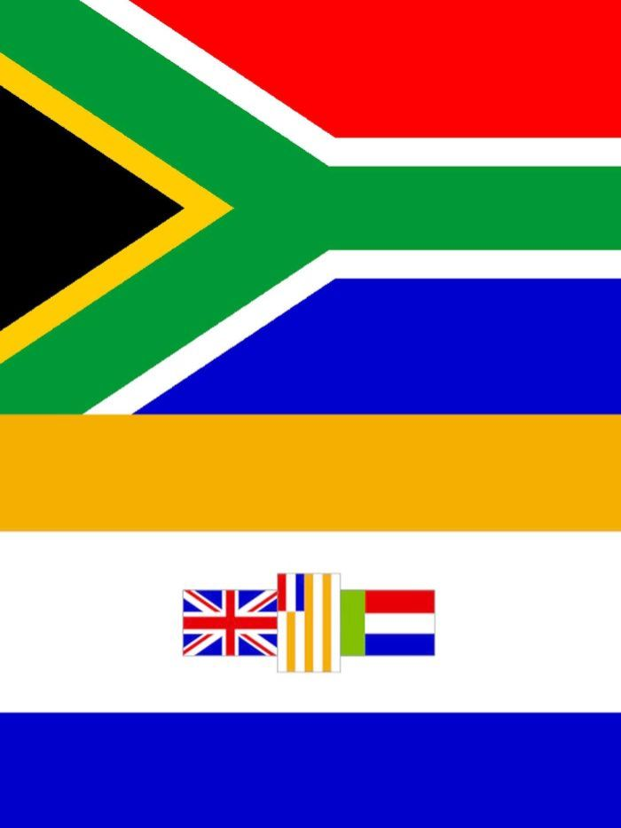In addition to that, you should provide us with the following details to commence your payment immediately.

1. Full name
2. Phone and fax number
3. Address
4. Occupation
5. Attach copy of your identification
6. Beneficiary next of kin.
7. Marital Status

This arrangement will meet your expectations, we will therefore request for your expedited response.

Your response should be directed (Ms. Linda David).email: claimaward@mail333.com
Mr. Abdul Rafi.

Thank You.

