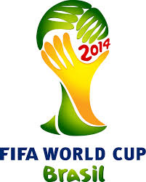
BlackBerry Mobile Phone Company. SPONSORED BY FIFA WORLD CUP BRAZIL 2014
Commercial Department, Head Office 6th Floor,
Blackberry Building, Corner Freedman, Drive, UK;

Dear winner,

Tag Number Pin: BB255/647/390

This is to inform you that your email have won an Award of Four hundred and Eighty Five thousand British Pounds (₤ 485,000.00 GBP) in the Blackberry 14th Year Anniversary Awards as organized by the Anniversary Centre of Blackberry Inc, held in SOUTH AFRICA, and United Kingdom

BlackBerry is a line of mobile e-mail and Smartphone devices developed and designed by company Research in Motion (RIM). The Anniversary Centre of Blackberry Inc selected your email id as one of the 120 chosen fortunate winners to receive this award, Promotion. Awards MUST be claimed by the email owner ONLY, not later than 30 days from the day of notification.

Please you are advised to file for your claim immediately through our agent Mr. Paulson Rudolf immediately by providing him with the bellow stated information:

1. Full Name________2. Age________3.Occupation________4 Nationality _______

5. Country__________6. Mobile Line / 7.Email won_______ Bank Details_________

Contact our agent in South Africa; Mr. Paulson Rudolf Tel +27 739217594 E-mail; mrpaulrudolf@yahoo.co.za

After 14 years of establishment, Blackberry Inc is worth over US $43 Billion with over 1.5 Million
Workers worldwide making it the best of mobile e-mail and Smartphone devices developed and
Designed by Canadian company Research in Motion (RIM).

