

2 Newton Close, Walsgrave, Coventry
West Midlands, England,
UNITED KINGDOM

JOHANNESBURG, SOUTH AFRICA

Motto: Your satisfaction is our priority



FACEBOOK EIGHT YEAR ANNIVERSARY PROMOTIONS FOR 2014

JOHANNESBURG, SOUTH AFRICA

Motto: Your satisfaction is our priority

Ref: FB/968/09
Batch: 409978E
Facebook / Yahoo Messenger Chat Executive! Prize Results, You won GBP£1,000,000.00! Facebook! Mail congratulates you! Facebook! / Yahoo Messenger! Company announces you as one of the 10 lucky winners in the ongoing face book emails prize draw for the year 2014.

All 10 winning email addresses were randomly selected from a batch of 50,000.000 international Emails each from Canada, Australia, United States, Asia, Europe, Middle East, Africa and Oceania. As part of our international promotions program which is conducted annually, consequently, you have been approved for a total pay out of GBP£1,000,000.00 (One Million Great British Pounds Sterling) Only

This facebook and yahoo messenger chat promotion was promoted and sponsored by a conglomerate of some multinational companies as part of their social responsibility to the citizens in the communities where they have operational base.

Further more your details (E-mail address) falls within our British representative office in United Kingdom, as indicated in your email box and your prize money of GBP£1,000,000.00 Equivalent to ($1,600,481.27 USD) will be released to You through our afflicted / corresponding assign payment bank.

HOW TO CLAIM YOUR PRIZE
Contact Facebook / Yahoo messenger chat agent for notice of claims.
Contact Fiduciary Agent:
Dr.Mrs. Elizabeth Henderson
Facebook / Yahoo Messenger Chat Award Services Center (U.K)

You’re instructed to send the completed verification form detail’s below to our agent in the United Kingdom whose email address is given below so that you will be advised on what to do to get your prize Money through our afflicted / corresponding payment bank here in England (United Kingdom).

Emails: awards92facebook@nokiamail.com, facebookboard@ovi.com, awardsfacebook@kimo.com
TEL :( +44) - 703 174 8924 / FAX :( +44) - 703 181 7995

FULL NAME:--------DATE OF BIRTH:----MARITAL STATUS----OCCUPATION:----HOME ADDRESS-----ZIP CODE:-------COUNTRY:--- NATIONALITY:----CELL NO----TEL:NO------FAX:NO-------
YOU CAN AS WELL ATTACHED YOUR BANK ACCOUNT DETAIL’S FOR THE TRANSFER OF YOUR FUNDS.

For security reasons, we advice you as one of a winner to keep your winning information confidential from the
public until your claim is proceed and your prize money remitted to your designated bank account of your choice.
This is part of our Facebook / Yahoo messenger chat online security protocol to avoid double claiming and unwarranted taking advantage of this program by non-selected winner or unofficial personnel.

Yours Sincerely,
Rev. William Gerri (PHD) FACEBOOK Co-coordinator England.
The Facebook / Yahoo Messenger Chat Staff.
For inquiry} do contact this email address here: facebookiboard6@nokiamail.com
Facebook Price Results!
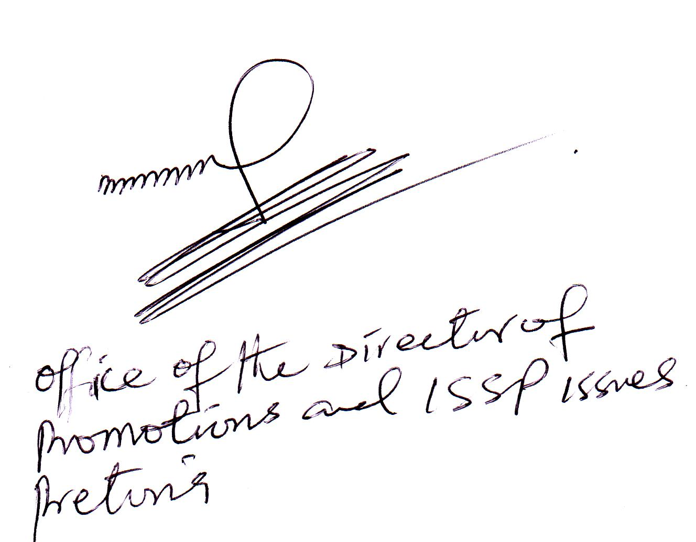
THIS FACEBOOK / YAHOO MESSENGER CHAT WAS SPONSORED BY THE BARCLAY’S PREMIER LEAGUE LONDON ENGLAND UNITED KINGDOM.
Tel: +44-703 174 7620
Fax: +44- 703 181 7995
Email: facebookboard@ovi.com
boardfacebook1@qatar.io

JOHANNESBURG, SOUTH AFRICA

Motto: Your satisfaction is our priority

