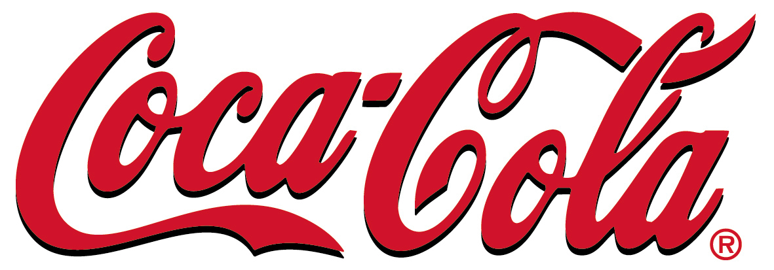
GREAT BRITAIN 1 QUEEN
CAROLINE STREET,
HAMMERSMITH LONDON W6 9HQ,

Dear Award Winner,
This is to inform you that you have won a prize money of £1000,000.000(One Millions Pounds Sterling’s) From Coca-Cola Lottery Promotion United Kingdom which is organized by Coca-Cola Company , “Your Email Address" were selected through a computer ballot system drawn from Nine hundred thousand E-mails from Canada, Australia, United States, Asia, Europe, Middle East, Africa and Oceanic as part of our international promotions program which is conducted annually, we have only selected 20 people as our winners, through electronic ballot System without the winners applying.
VERIFICATION AND FUNDS RELEASE FORM
---------------------------------------------------------------------
1. Full Name: ……………
2. Address: ………………
3. Sex: ………………………
4. Age: ……………..
5. Mobile Number: ……….
6. Occupation: ………………
7. State: ………………………
8. Country: …………………… 9.Winning E-mail: ..................
To file for your claim, Please fill and submit your verification form to our Foreign Service Manager Immediately via e-mail below.
Dr. Bright Morrison
Foreign Service Manager
Coca-Cola Lottery (Pty) Ltd.
Tel: +44-7010020594
E-mail: colawin1coca@outlook.com
http://www.coca-cola.com/music/en_US/125year/postlive.html?lang=en

I want to congratulate You In Advance and Please Do Not Forget to Help the Poor in the Society, When Coca-Cola Makes You a Beneficiary Of their World of Wealth.
Congratulations once again on your winning!!!

Yours Faithfully,
Bright .m.
Chairman of the Board & Chief
Executive Officer the Coca-Cola Company Plc United Kingdom


©”COPYRIGHT 2014 COCA-COLA ONLINE PROMOTION ALL RIGHT RESERVED

