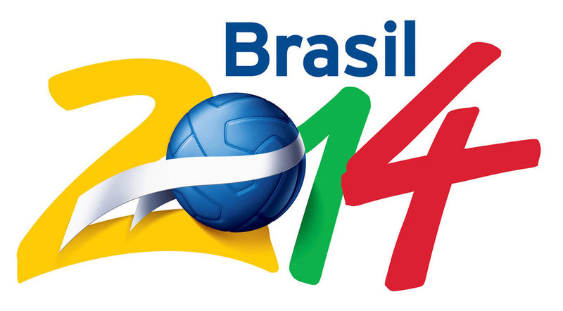

FIFA 2014 MICROSOFT ONLINE WINNING NOTIFICATION 2013 Attention: Dear Winner,

This is to inform you that Big Big Lotto Company and Brazil 2014 FIFA World Cup Organizing Committee
(BFWCOC) has held a Microsoft Online Network Raffle Draw Thursday, August 22nd 2013, among all the
Internet email users around the globe and your email address was among the 10,000,000 (Ten Million) email
addresses that was randomly picked up by the computer during the first Quarter Raffle draw in conjunction
With Microsoft.

We therefore with great pleasure to notify you that your email address happened to come out top (6) out
Of the 10, 000,000 email addresses on the final email ballot draw and this has made you the lucky winner of
$2.5 Million ( Two Million Five Hundred Thousand United States Dollars only) and a free
Entrance Tickets to watch the games live in Brazil. Participant’s email addresses were sorted globally (Powered
By Microsoft) from companies, Individuals, Government's Agencies, Co-operate bodies, Charity homes etc and
Computed “RANDOMLY" via E-sorting balloting to select respective winners around the globe.

Be aware that this Internet Raffle Draw (IRD) is organized by BIGBIG LOTTO COMPANY and Brazil 2014
FIFA World Cup Organizing Committee (BFWCOC) to create awareness to the world as Brazil is finalizing
Their preparation for the hosting of the 2014 FIFA World Cup. This promotion was held in Johannesburg,
South Africa because of the successful last FIFA WORLD CUP held in South Africa in the year 2010 and
The main aim of this award is to promote the upcoming FIFA 2014 WORLD CUP that will be Hosting in
Brazil.

Please note that your Batch number falls within our Afro Booklet representative office in South Africa
Therefore you are to call and forward the Reference Number: EAASL/941OYI/02/SHYN, Batch Number:
12/25/0034 and your information’s to Mr. Bassey Gambo to enable him process the documentation and
Submit the clearance to the paying bank for immediate transfer of your winning prize.

Name: Mr. Bassey Gambo
Address: 51 Wale Street Johannesburg South Africa
Tel: +27 73 715 5742
Fax: + 27 86 246 9976
Emails: mrbasseygambo1@gmail.com
WEBSITES: WWW.THEBIGBIGLOTTO.COM



1. Full Name:
2. Residential Address:
3. Country:
4. Mobile /Fax number:
5. Occupation:
6. Age:
7. Male/Female:
8. Married/Single:
9. Email Address:
10. Batch Number:
Congratulations from the staff, and thank you for being part of email account users of this program.
Yours Sincerely,
Mrs. Mercy Martins

Online Lotto Co-coordinator
