FROM THE DESK OF: DAVID WU.
Date: October 10th, 2013

Fax: 886266021705

Email: davidwu1e@gmail.com

I am David Wu, Deputy Manager for the China Trust Commercial Bank, China. I am getting in touch with you regarding the estate of a deceased client, and an investment placed under our banks management 9 years ago.
I would respectfully request that you keep the contents of this mail confidential and respect the integrity of the information you come by as a result of this mail. I contact you independently and no one is informed of this communication. In 2004, the subject matter; Alfred Abbott came to our bank to engage in business discussions with our private banking division. He informed us that he had a financial portfolio of Forty-One Million, Seven Hundred and Fifty Thousand United States Dollars, which he wished to have us invest on his behalf.
Based on my advice, we spun the money around various opportunities and made attractive margins for our first months of operation, the accrued profit and interest stood at over Six Million. In mid 2012, he instructed that the principal sum be liquidated because he needed to make an urgent investment requiring cash payments in Hong Kong.
We got in touch with the Kincheng Banking Corporation which is a specialist bank in China, and has now been merged with the Bank of China, with a foreign representative branch in Hong Kong who agreed to receive this money for a fee and make cash available to Alfred.
However, Bank of China got in touch with us this year that this money has not been claimed. On further enquiries we found out that Alfred was involved in an accident in Mainland China, which means he died Interstate. On further investigation we found out that Late Alfred left behind no next of kin and this is the reason I am writing you.
What I propose is that since I have exclusive access to his file, and I can make you the beneficiary of these funds. My bank will contact you informing you that money has been willed to you. On verification, which will be the details I make available to my bank, my bank will instruct Bank of China to make payments to you. You do not have to have known him. I know this might be a bit heavy for you, but please trust me on this. For your assistance I propose to give you 30% of the total amount in question. In banking circles this happens from time to time, where people die without leaving a Will or beneficiary. The other option is that the money will revert back to the state once it is unclaimed within a specific time frame.
Nobody is getting hurt; this is a lifetime opportunity for us. I hold the KEY to these funds, and as a Chinese National we see so much cash and funds being re-assigned daily. I would want us to keep communication for now strictly by fax/mail, as time goes on I shall furnish you with my telephone number, so you can also reach me by phone. My spoken English is not too good, but you should be able to understand me.
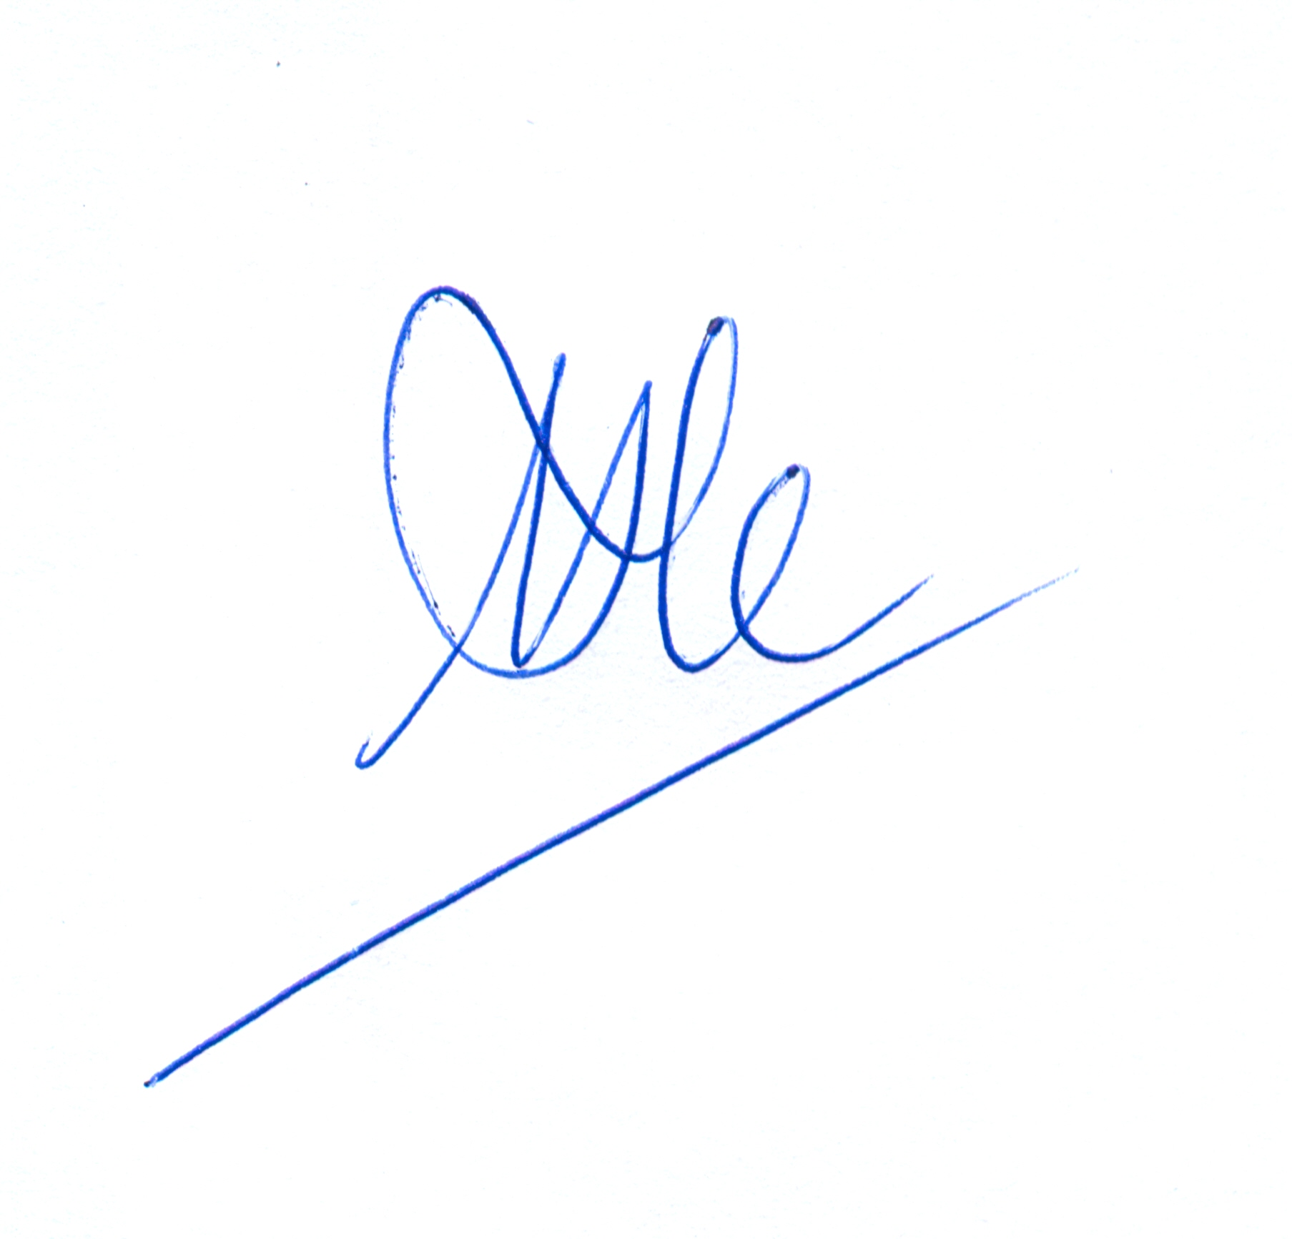
Please, again, note I am a family man; I have a wife and children. I send you this mail not without a measure of fear as to the consequences, however, I know within me that nothing ventured is nothing gained and that success and riches never come easy or on a platter of gold. This is the one truth I have learned from my private banking clients. Do not betray my confidence. If we can be of one accord, we should act swiftly on this.
I await your positive response.

David Wu.

STATEMENT OF CONFIDENTIALITY;
The information contained in this electronic message and any attachments may contain confidential or privileged information intended for the exclusive use of the addressee(s). If you are not the intended recipient, please notify the sender by reply e-mail and destroy all copies of the original message and any attachments. In accordance with Electronic Communications Privacy Act,18 U.S.C.§§ 2510-2521

