TOYOTA CAR INT. PROMOTION PROGRAM


TOYOTA INTERNATIONAL LOTTO (HEADQUARTERS)
Customer Service Department Affiliate of Toyota Japan.
#28 Kanashiwa road, Tokyo JP

Ticket number..................... 719-266-1319
Serial number....................... 902-66
Lucky number................... 5, 12, 30, 11, 17, 43, and bonus number 12
Insurance number................... FLS433/ 453L /G MSA

CONGRATULATIONS! CONGRATULATIONS!! CONGRATULATIONS!!!

Dear Winner,

We are pleased to inform you of the announcement made today, You are among the winners of the TOYOTA CAR INTERNATIONAL PROMOTION PROGRAM Participants who were selected through a computer ballot system drawn from 8,500,000 email addresses of individuals and companies from all part of the world as part of our electronic business Promotions Program.

As a result of your visiting various websites, we are running the e-business promotions for You/Your Company email address, attached to ticket number 719-266-1319, with serial number 902-66 drew the lucky numbers 5, 12, 30, 11, 17, 43 and Bonus number 12, Your Insurance Number: FLS433/ 453L /G MSA and consequently you won in the Second Category of the TOYOTA FORTUNE LOTTO DRAW.

You have therefore been approved for the payment of the sum of $1,000,000.00USD (one million United States dollars) in cash, including a 2013 Toyota Highlander Hybrid Limited 4X4 base, which is the winning present /amount for the Second category winners. This is from the total prize money of $3,000,000.00USD shared among the international winners in the Second category.

Please be informed that your won fund of the sum of $1,000,000.00USD is now with the payee center. Contact our agent and give them your full names so that they will re-insure your winning fund under your full names. Together with the port where the winning car should be shipped to.

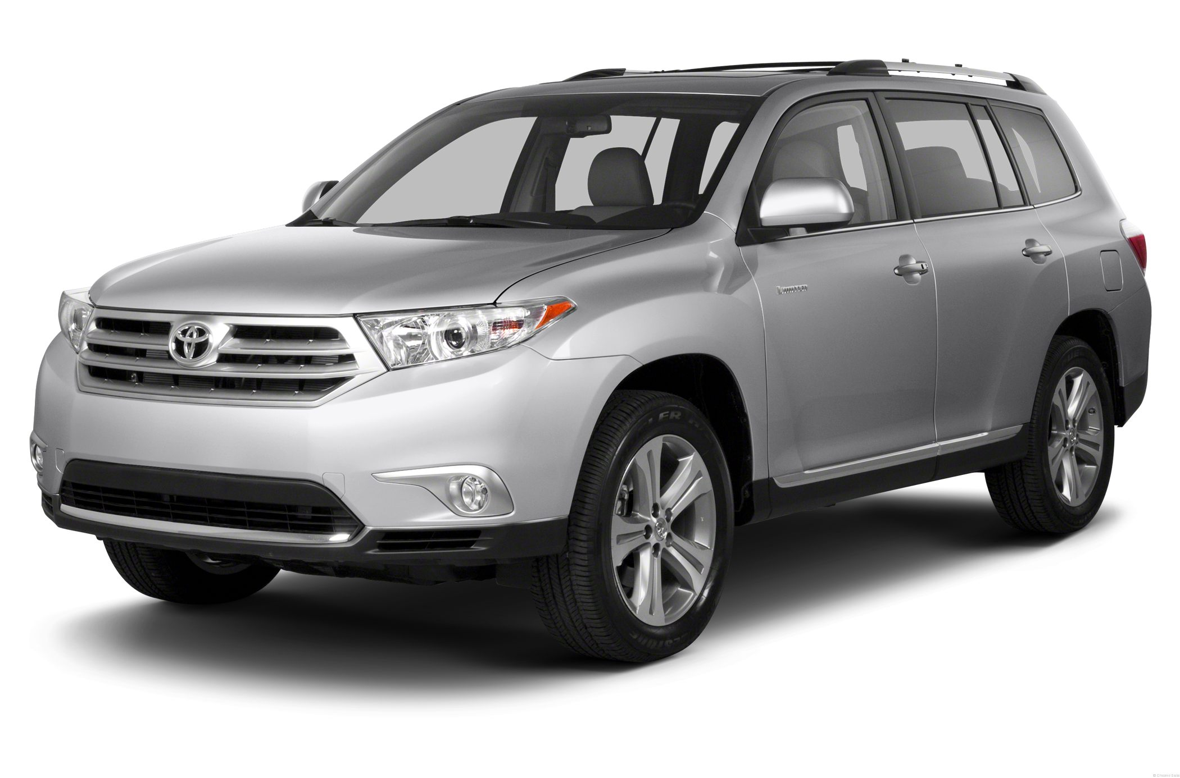
To file for your claim, please contact our Claim Agent/Hon. coordinator immediately

Name: Wilson Zhang
Email: admin@tparspromo.com
Tel: 00861-3418386734

CONGRATULATIONS!!!! Once again from all members of our staff and thank you for being a part of our International Promotions program.

We wish you continued good fortunes.

Yours sincerely,
Mrs. Zhang Wei,
Hon. Coordinator.

Please provide the following details for processing of your claim.
VERIFICATION FORM
1, Names in full:
2,Country of Residing:
3, Nationality:
4,Residential Address:
5, Date of Birth/Age:
6, Marital Statue/Sex:
7, Tel/Fax:
8, Mobile No:
9, Occupation:
10, Company:
11, Alternative email if any:
12, Ticket No:
13, Serial No:
14, Ins. No:

TOYOTA CAR INT. PROMOTION PROGRAM
Copyright 2013 Toyota Lottery promotion All Right Reserve

