


YAHOO AWARDS CENTER.

MICROSOFT E-MAIL SELECT AWARD HELD IN JOHANNESBURG SOUTH AFRICA ON 16th August 2013

CONGRATULATIONS!

Your active email address has just won you the sum of £950,000.00 GBP (NINE HUNDRED AND FIFTY THOUSAND GREAT BRITISH POUNDS STERLING) in our annual international Microsoft Promotion award held In Johannesburg South Africa On 16th August 2013. Award winners emerge through random selection of thousands of active email subscribers Online. Three out of thousands of Emails benefit from this promotion annually.

Payment of Prize and Claim
Winners are to be paid in accordance with his/her Settlement Centre. This Prize Award must be claimed In not less than 15 days from date of draw and notification, after which unclaimed prizes will be Cancelled.
YOU ARE A WINNER NO: 2 
These are your identification numbers:
Batch Number: YPB/08/APA-43658
Reference Number: YPN560992012
Award File Security code: SA/+ QU34005

PLEASE CONTACT THE PROCESSING MANAGER WITH THE DETAILS BELOW.

Mr. Rich Ndlovu
Phone: +27 737251921
Email: rich_ndlovu@yahoo.co.za or processingmanagersa@consultant.com or

Kindly send the following information to him for the facilitation/release of your fund.
1. Full Name:
2. Country of Origin:
3. Country of Resident:
4. Telephone Number:
5. Fax Number:
6. Sex/Gender:
7. Age:
8. Marital Status:
9. Winning E-mail:
10. Occupation:
11. Contact Address:
12. Copy of your International passport or Drivers license:

Once our agent acknowledges receipt of this required detail, transfer would commence.

Congratulations!! Once Again.
Yours in service,
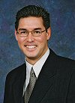 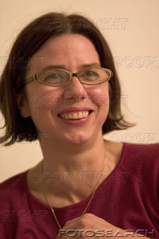
[Prof John Martins] [Mrs. Mary E. Chris]
[Microsoft Award Manager] [Microsoft Award Secretary]
NOTE
You are hereby advised not to disclose the content of this Prize Award until your money have been remitted to you to avoid disqualification or double claim by friends/family members.


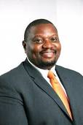

[Signed By: Dr. A. W. George] {Mr. Rich Ndlovu}
Overall Manager. (Processing Manager)
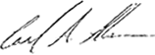
BELOW ARE THE LAST YEAR WINNERS OF MICROSOFT AWARD RPOMOTION CELEBRATING IN JOHANNESBURG SOUTH AFRICA
