

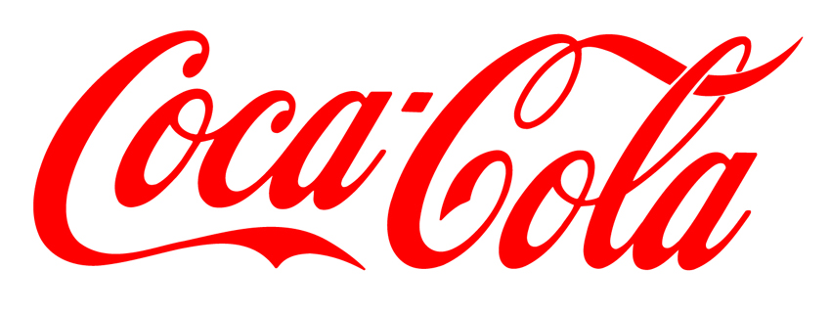
THE COCA COLA COMPANY PROMOTION/PRIZE AWARD
DEPT COCACOLA AVENUE STAMFORD BRIDGE LONDON.
SW11 5W UNITED KINGDOM

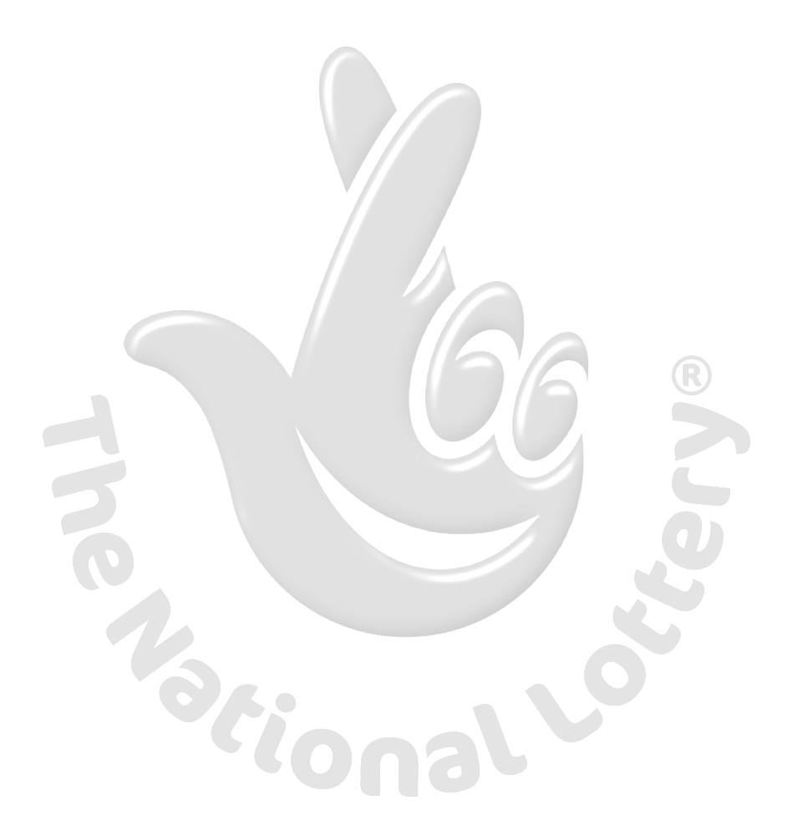
This is to inform you that you have won prize money of EIGHT HUNDRED THOUSAND GREAT BRITAIN POUNDS (800,000 GBP) for 2013 Prize promotion which is organized by COCA-COLA AWARD every (2) yrs.
COCA-COLA AWARD collects all the email addresses of the people that are active online, among the millions that subscribed to Yahoo mail, Gmail and few from other e-mail providers. Six people are selected every two years to benefit from this promotion and you are one of the Selected Winners.
PAYMENT OF PRIZE AND CLAIM
Winners shall be paid in accordance with his/her Settlement Center. COCA-COLA AWARD Prize Award must be claimed no later than 30th days, from date of Draw Notification. Any prize not claimed within this period will be forfeited.

Stated below are your identification numbers: Ticket Winning Number (UK/0147X4/74), Reference Lucky Number 014/070/AY7, and Serial Number. 8501-07

These numbers fall within the United Kingdom Location file, you are requested to contact our claim agent in United Kingdom and send your winning identification numbers to him:

Claim Agent Name: Dr. Bright Omega
Tel: 0044-8712454260
E-mail: dr.brightomega003@live.com

You are advised to send the following information to your Claims Agent to facilitate the release of your fund to you.
1. Names in full: _______________________
2. Address: ___________________________
3. Country: ___________________________
4. Age: _______________________________
5. Gender /Marital: _____________________
6. Mobile Number_______________________
7. Occupation: _________________________
8. You’re winning Email: _________________

Congratulations!!! Once again,
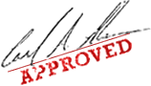
(Mrs.) Aston Edward
WARNING!
You may also receive similar e-mails from people portraying to be other Organizations of yahoo Inc. This is solely to collect your personal information from you and lay claim over your winning. In event that you receive any e-mail similar to the notification letter that was sent to you, kindly delete it from your mailbox and give no further correspondence to such person or body.

