TOYOTA PROMOTIONS 2013 WINNING NUMBER:88-12-45-98-56
IDENTIFICATION CODE: TY/020
2 Lansodowne Row,Berkeley Square, London, W1j 6h, United Kingdom
DEAR LUCKY WINNER

CONGRATULATION: CONGRATULATION:

REGARDING THE WINNING OF YOUR AWARD PRIZE WHICH YOU WON IN OUR (2013) PROMOTION PROGRAM, WE ARE HAPPY TO CONGRATULATE YOU ONCE MORE FOR BEING ONE OF AMONG THE SELECTED WINNERS. BE NOTIFIED THAT A RESOLUTION HAS BEEN MADE AND DECISION TAKEN BY THE AUTHORITIES OF TOYOTA CAR BOARD OF DIRECTORS ENGLAND DUE TO THE LAWS & POLICIES IMPOSED ON MONETARY TRANSACTION BY THE AMERICAN GOVERNMENT TO CHECKMATE MOVEMENT, SOURCES OF FINANCES SUBJECTING IT TO SECURITY AND MAKING SURE THEY ARE FREE FROM TERRORISM, MONEY LAUNDRY & RELATED FINANCIAL OFFENSES AS RULED IN THE WORLD COURT.

OUR ONLINE DRAWS E-MAIL ADDRESSES OF CURRENT INTERNET USERS SUPPLIED BY YAHOO, HOTMAIL, MAIL.RU LYCOS, TERRAMAIL, WEEDMAIL, JUSTICE MAIL, REDIFFMAIL,GMAIL, ETC. THE MODE OF WINNERS SELECTION IS THE ELECTRONIC MAIL MOBILE PHONE BALLOT SYSTEM. YOUR MOBILE PHONE NUMBER OBTAINED A RAFFLE TICKET ON THE BASIS OF OUR CURRENT INTERNET USE, AND PROCEEDED TO THE FINAL DRAWS ALONGSIDE 99, OTHER E-MAIL ADDRESSES. AND IT EVENTUALLY EMERGED AS ONE OF THE TEN (10) WINNERS IN THE 2013 GRAND FINALE DRAWS CONDUCTED AT OUR HEADQUARTERS IN HERE IN UNITED KINGDOM. SEQUEL TO THIS, YOU HAVE WON A BRAND NEW CAMRY SOLARA TOYOTA CAR 2013 WORTH $33,500.USDOLLARS (PICTURE APPEARS BELOW
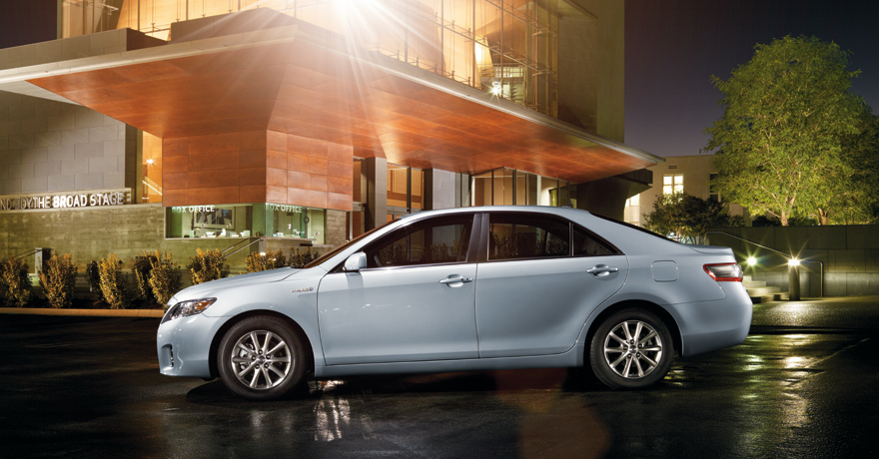

Camry solar a (2013) price: $33,500

IN ADDITION, YOU HAVE ALSO WON THE FOLLOWING: 550.000.00 GREAT BRITISH POUNDS STERLING
PRIZE GIVEN TO YOU FOR YOUR (ACCOMODATION ALLOWANCE, AND (2YEARS HEALTH ALLOWANCE)
(UNDER MISCELLANEOUS BILLS)

WE HAVE MADE EVERY ARRANGEMENT AND HAVE PAID THE SHIPPMENT OF YOUR CAMRY SOLARA TOYOTA CAR ON OUR DELIVERY. THUS,
A TOTAL AMOUNT OF 550.000.00 GREAT BRITISH POUNDS STERLING AND A CAMRY SOLARA TOYOTA 2013 ARE IN YOUR FAVOR.

Please you are advised to complete the form below and send it immediately to your Promotion Fiduciary Claims manager through email for prompt collection, processing and immediate delivery of your winning amount to you in your country.
FIRST NAME................................................... LAST NAME...................................................
AGE........................................................ SEX..............................................................
ADDRESS................................................... EMAIL.........................................................
PHONE......................................................... OCCUPATION..................................................
COUNTRY.............. .................................. AMOUNT WON..................................................
Kindly send these information to this email ID: toyota-redemption@hotmail.com
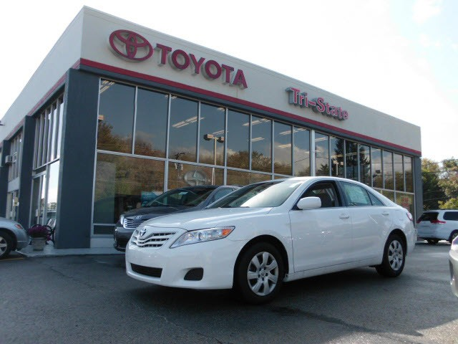

Camry solar a (2013) price: $33,500
Congratulations
CONTACT: TOYOTA PROMOTIONAL CLAIMS MANAGER
NAME: Dr. Alex Williams
E-MAIL: toyota-redemption@hotmail.com
TEL: +447014245028

