
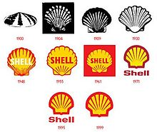

Shell Centre, London, SE1 7NA - United Kingdom
Incorporation Barley House, Hare Road
Sutton, Great Britain SM1 4te
United Kingdom. Tel:+447010036562

Dear Winner,
We are happy to inform you of the Shell Oil Company United Kingdom (UK) 60years Anniversary Promotion, held on the (28th ^{Of} March 2013) for Email Address Users Worldwide Promo,

Your Email was luckily drawn by a computer balloting system as one of our winners in our online promo bonanza from the prestigious UK SHELL OIL COMPANY ONLINE PROMOTION. Thus, making you the winner of the sum of £500,000.00GBP (Five Hundred Thousand Great British Pounds Sterling’s).


This is to let you know that this online world e-mail draws was conducted from an exclusive list of 25,000 company e-mail addresses, 30,000,00 individual e-mail addresses from over 40 networks and corporate bodies were picked by an advanced automated random computer selection from the web.
Please complete the form below with correct information and email back to us with a return email so that we can have a precise and comprehensive record of our winners and also provide you on how you will receive your winning amount.

To proceed with your claims, you would be required to fill the Verification Form below completely and return back to your prize administrator MR. FRANK JONES immediately via: E-Mail: shelloiluk44@hotmail.com

VERIFICATION AND FUNDS RELEASE FORM


1. FULL NAMES:
2. ADDRESS:
3. SEX:
4. AGE:
5. MARITAL STATUS:
6. OCCUPATION:
7. TELEPHONE NUMBER:
8. MOBILE NUMBER:
9. AMOUNT WON:
10. STATE:
11 COUNTRY:
12. WINNING EMAIL:
13: SCAN COPY OF YOUR IDENTITY PROOF:
Do not tell people about your Prize Award until your money is successfully handed over to you to avoid disqualification that may arise from double claim.
SHELL OIL COMPANY UK shall not be held responsible for any loss of fund arising from the above mentioned. PLS SEND YOUR REPLY TO YOUR PRIZE ADMINISTRATOR: E-MAIL: shelloiluk44@hotmail.com
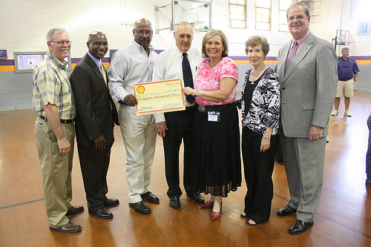

MR. FRANK JONES, TELL: +447014233079 +447010041748
(PRIZE ADMINISTRATOR SHELL OIL COMPANY UK 2013 AWARD)

