
22 Garden close Stamford
LicePE92Y, London
United Kingdom, England
COCA COLA NATIONAL ONLINE E-MAIL AWARD DRAW UK /2013

ukcocla@hotmail.com

We want you to remove every skepticism from your mind because this award is legitimate from COCA-COLA COMPANY ENGLAND,

Your Email was luckily drawn by a computer balloting system as one of our winners in our Online lottery bonanza from the prestigious COCA-COLA ONLINE PROMOTION. Thus, making you the winner of the sum of 500,000.00GBP (Five Hundred Thousand Great British Pounds Sterling’s).

Please complete the form below with correct information and email back to us with a return email so that we can have a precise and comprehensive record of our winners and also provide you On how you will receive your winning amount.

Your prize cheque has been vaulted safely with our corresponding Bank prior to your readiness to complete your claims and would be presented to you after verification of the data requested below.

These are your identification:
Lotto number...........C.C.UK/0048/0936HP
Winning number......C.C.UK/ 0008857
Winning Amount......£500,000 GBP
Batch number..........C.C.UK/OP/00142/2013

To proceed with your claims, you would be required to fill the Verification Form below completely and return back to us immediately.

Fill Out This Form Verification Form
1. Full Names :
2. Your Date of Birth:
3. Your Full Address :
4. Your Country
5. Your Current City:
6. Your Occupation:
7. Sex :
8. Marital State :
9.Winning Email Address:
10. Your Mobile Number:

You are request to fill below bank information and send it back to us:-
1, Bank Name :
2, A/C Number:
3, A/C Name:
4, Swift Code:
5, Mobile number:
6, branch:

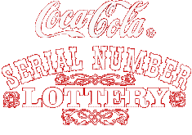
BATCH/REFERENCE NO: C.C.UK/OP/00142/2013.
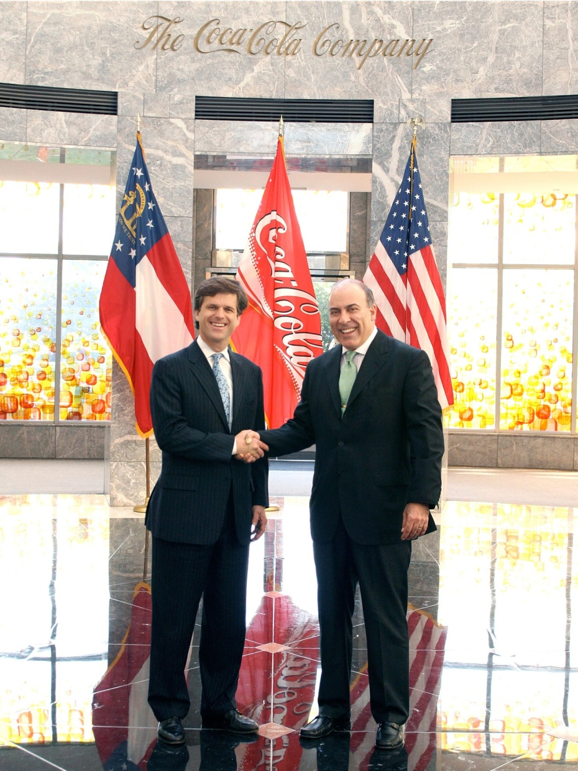
Prof. Alex Kingston and Dr. George Williams,
Past Winner in Coca-Cola Company Online Promo England,
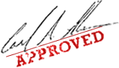
Sincerely yours,
DR. MACK ANTHONY,
COCA COLA COMPANY ONLINE PROMO CO-ORDINATOR.
Tel: +447010054442




From The Coca Cola Company Promo.
kindly contact us for more details on how you can redeem your winning prize

For security reasons, you are advised to keep your winning information confidential till your claims is processed and your money remitted to you in whatever manner you deem fit to claim your prize. This is part of our precautionary measure to avoid double claiming and unwarranted abuse of this program. Please be warned.
NOTE : ALL MAILS REGARDING CLAIMS SHOULD BE REPLY TO
EMAIL- ukcocla@hotmail.com

