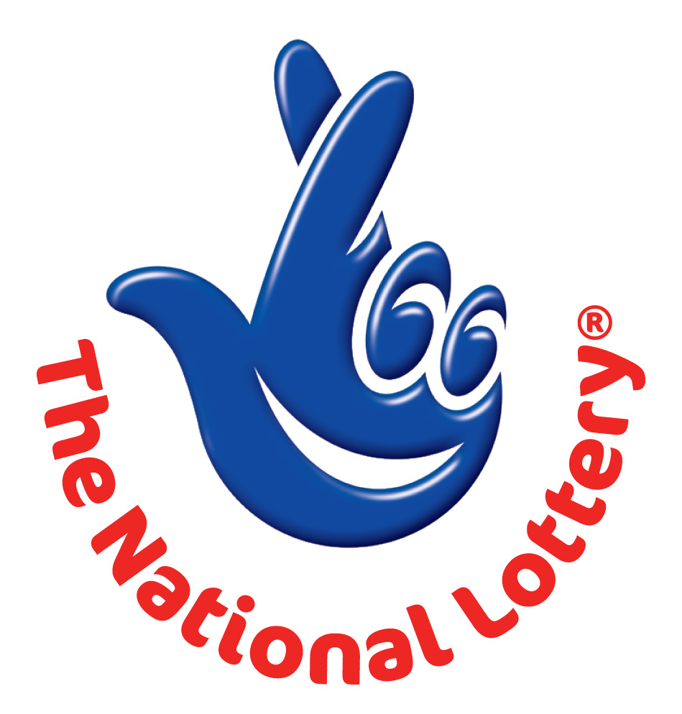
CANADA LOTTERY/ EMAIL DRAW ONTARIO 49
1550 Princess Street Kingston, ON, Canada, K7M 9E3
Website: http://www.lottolore.com/ontario49.html
UK Office No 47 Se1 7na – Balking London United Kingdom
24hrs.Tel: +44 (0) 703 1746 641
Email: canadian_ontario_49@hotmail.com

Wed, April 17, 2013 - Ontario 49 LATEST Draw

WINNING NUMBERS
2 | 12 | 20 | 22 | 30 | 37 | Bonus 24

Attn: Winner,

We happily announce to you the draw of Canadian National Lottery the UK/CANADA online Sweepstakes International program held on Wednesday 17 April 2013.

You have won USD$1,000,000.00 (One Million United States Dollars Only) from Canadian Ontario 49 lottery draw 2013 edition.
Your Email ID was one of the selected emails from worldwide websites in the lottery draw that took place in Manchester, England on Wednesday 17th April and it come out as one of the lucky winning number.

For us to process your winning fund for transfer you are advice to contact our judiciary agent with the details below for your payment.

Name: Mr. Owen Ferguson
Email: owenfergusonnuk@hotmail.com/ kambdu@gmail.com
Telephone: +44 70317 445 07

Please forward to him the following details below

1. Name (in Full):
2. Country:
3. Address:
4. Direct Telephone No:
5. Age:
6. Occupation/position:
7. Winning Number:

Congratulations!! Once again.

Yours in service,
Mrs. Evelyn McGregor
[Publicity Secretary]

