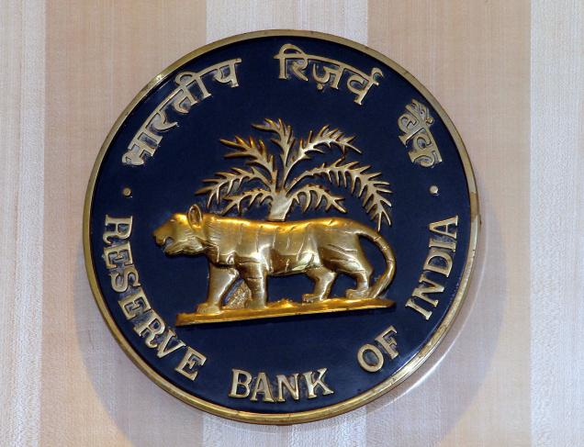
Reserve Bank of India
regional office,
Foreign Remittance Department.
6, Sansad Marg 110 001,
New Delhi, India.

Payment file: RBI-DEL/id1033/13.
Payment amount: $ 500,000. US Dollars.

RESERVE BANK OF INDIA OFFICIAL PAYMENT NOTIFICATION
Attn: Beneficiary,
The Foreign Exchange Transfer Department of Reserve bank of India wish to bring to your attention that you were listed as a beneficiary in the recent schedule for payment of outstanding debts incurred by the BRITISH GOVERNMENT pending since 2007 to 2013. According to your file record with your email address. Do be informed that this is not a lottery but it is a United Kingdom Government Compensation to you to help you. Your payment is categorized as:
Contract type: Lottery/inheritance/ unpaid contract funds/ Undelivered Lottery fund/Un transferred Loan/Pending Pension fund.
Furthermore, The Reserve Bank of India (RBI) Governor, Dr D. Subbarao and Ban Ki-moon Secretary-General of the United Nations met with the Senate Tax Committee on Finance at New Delhi regarding unclaimed funds which have been due for a long period of time. At the end of the meeting, RBI Governor Dr. D. Subbarao mandated that all unclaimed funds should be released to the beneficiary stating that it is an unfair practice to withhold funds for government basket for one reason or the other for tax accumulations or other process. Therefore, we are writing this email to inform you that $500,000 US DOLLARS will be released to you in your name as it was sent from the British Government and as it was also committed to RBI Governor that each beneficiary will have to pay approval fee of (13,500 INR only in cash deposit) so that the assigned check from United Kingdom issued from Barclays Bank can be approved for clearance in India before it can be credited into your account provided by you. Hence, you are therefore required to pay 13,500 INR only in cash deposit and kindly send Xerox copy of pay-in-slip for confirmation.
NOTE: The approval fee of (13,500 INR) cannot be deducted from your cheque because it has not been approved. Also note that the $500,000 US DOLLARS is covered with Insurance Policy by the British Government to ensure that the money will reflect into your account in full.
Please you are advised to fill the form below and email it to Mr. Clifford Joseph (britishhighcommission@chef.net) of Foreign Transfer Department for verification and prompt collection of your fund.
Fill The Form Below:
1. Full Names:
2. Residential Address:
3. Mobile Number:
4. Occupation:
5. Sex:
6. Age:
7. Nationality:
8. Country:
9. Marital Status:
10. E-mail id:
11. Bank Name:
12. Account Number:
13. Account Holders Name:
14. Bank Branch:
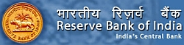
RESERVE BANK OF INDIA (CENTRAL BANK)
CONTACT TRANSFER DEPARTMENT
EMAIL: britishhighcommission@chef.net
NOTE: If this mail was wrongly sent please kindly forward it back to (britishhighcommission@chef.net)
Do not reply to this message to avoid double claim of Fund. Please Be Warned!!!
You are to keep all information away from the general public for security reason. Claim your ($500, 000.00) United State Dollars.

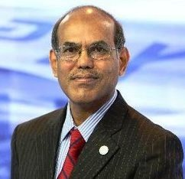
DR D. SUBBARAO.
RESERVE BANK OF INDIA
GOVERNOR
Accept my hearty congratulations once again!
Yours faithfully, Dr D. Subbarao

