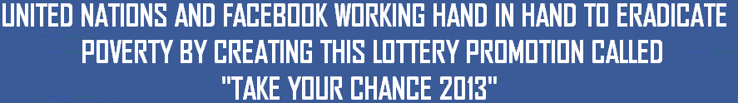


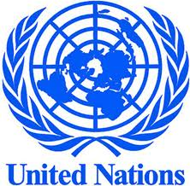
UNITED NATIONS & FACEBOOK AWARD CENTER.

UNITED NATIONS IN-CONJUNCTION WITH FACEBOOK AWARD
HEADQUARTERS: 760 UNITED NATIONS PLAZA, NEW YORK, NEW YORK 10017, UNITED STATES OF AMERICA.
DEAR WINNER

Your email addresses have just won UNITED NATIONS IN-CONJUNCTION WITH FACEBOOK AWARD prize money of (EIGHT HUNDRED THOUSAND GREAT BRITAIN POUNDS) (£800,000.00 GBP) On Mouth Of March 2013 Award Winners emerge through random selection of all active email subscribers and facebook online users, seven (7) people are selected monthly to benefit from this promotion.

TO FILE FOR YOUR CLAIM
Winners are to be paid in accordance with his/her Settlement Center. This Prize Award must be claimed not later than 20 working days from date of draw notification after which unclaimed prizes are cancelled.
These are your identification numbers:
Reference Number: FBUN/UNFB/2013/0102
Batch Number: FBUN/UNITEDNATIONS/FACEBOOK/0102
Award Organizing File Code: ZA/FBNU//0102/2013
These numbers fall within the African Settlement Centre; this means that you will need to claim this prize from South Africa. Thus, you are requested to contact our Releasing Manager in Johannesburg South Africa and send your winning identification numbers to her with the below personal requested information:

CONTACT INFORMATION OF OUR RELEASING MANAGER IN SOUTH AFRICA.
NAME: DR. NAPOLEON BEST
TELEPHONE: +27 74-976-3418
FAX NUMBER: +27 866-18-4101
E-MAIL: bestnapoleon11@gmail.com

Kindly send the following information to your claim agent to facilitate the release of your fund.
1. Full Names:……………………………………………………………………………
2. Country of Residence:…………………….Nationality:………………………
3. Mobile:………………………….Telephone Number:…………………………..
4. Fax Number: ………………………………………………………………………….
5. Gender:………………………….Winning Email:…………………………………
6. Date of Birth:………………………… Marital Status…………………………..
7. Full Address:……………………………………………………………………………
8. Your Company Name:……………………………………………………………….
9. Occupation:……………………………………………………………………………..
Once your Releasing Manager acknowledges the receipt of the above request details, she will get back to you immediately with the modalities on how the release should be made.

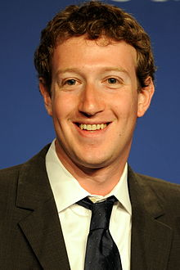
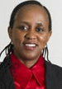
CONGRATULATIONS!! ONCE AGAIN!
YOURS IN SERVICE,
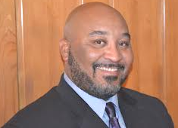

[DR. NAPOLEON BEST] [MRS. ROSSY INNOCENT] (MR.MARK ELLIOT ZUCKERBERG)
RELEASING MANAGER LOTTERY ORGANIZER CHAIRMAN AND CEO OF FACEBOOK
NOTE
You are hereby advised not to disclose the content of this Prize Award to anybody, until your prize money have been remitted to you to avoid disqualification that will arise from dual claim.

