TOYOTA:TOYOTA IN THE WORLD 2013 AWARD PROMOTION.
UNITED KINGDOM

COMPANY REGISTRATION NO.2352348
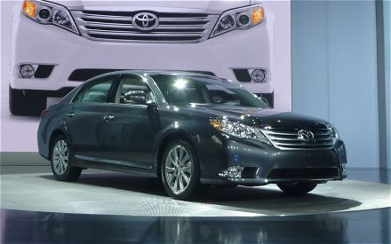
Dear Lucky Winner,

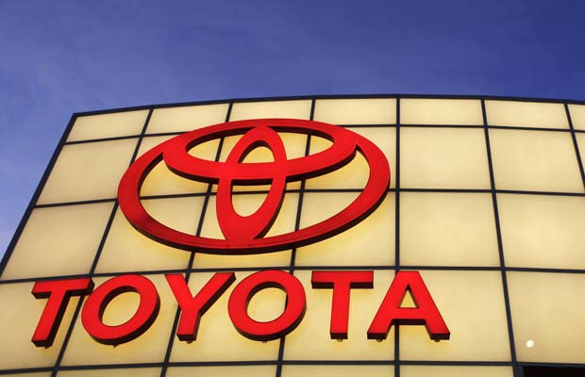 | Announcement!!!  This is a formal notification of the just concluded final draws of the Toyota: Toyota in the world 2013 award promotion held on January 01st '2013. In United kingdom. You have been approved to be paid a winning sum of? (£1,000,000.00) 0ne million Great British Pounds Only.
CONGRATULATION!! CONGRATULATION!! CONGRATULATION!!

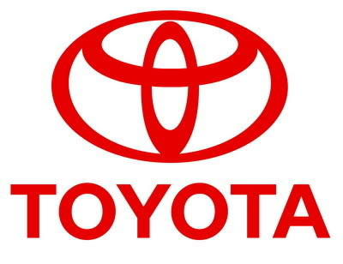
TOYOTA AUTOMOBILE COMPANY LTD.
Burnaston A38/A50,
Deryshire East Midland De1 9ta
United Kingdom.
COMPANY REGISTRATION NO.2352348
Read more: http://www.toyota.co.jp
TEL : +447010041877
OR:+447010041502
FAXMAIL: +447017036983
Reply To Email: toyotaprizedraw@live.com

STAR PRIZE WINNER
The online world email id draws was conducted from an exclusive list of 7, 000, 000 Email id of individuals and corporate bodies picked by an advanced automated random computer selection from the web. No tickets were sold. After this automated computer ballot, Your email-id, Batch Number :MS031/966 & Reference Number:DTC70054E was emerged as one of the five winners in category "B" with the followings:

Winning Amount: (£1,000,000.00 One million Great British Pounds) only

Your fund has been deposited in our bank here for security reason, and you are to fill the form provided below and forward it back to us for verification and confirmation
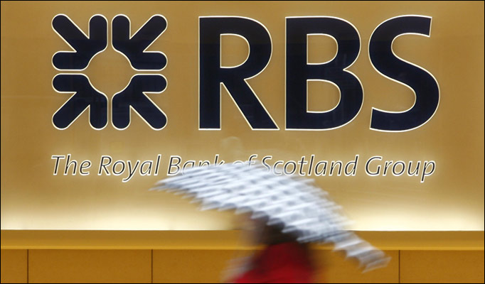
ROYAL BANK OF SCOTT LAND PLC' UNITED KINGDOM

This is to make your claims totally legal also to enable the bank release the fund and this process will not take more than four banking days.

I write to lay claims over my winnings as was announced by the Toyota Automobile Company (U.K) I was made to understand that this fund was deposited in a temporary account in your Bank by the above mentioned Organization Toyota Automobile Company Ltd.
PROVIDE YOUR FULL DETAILS BELLOW:

1. Full Name:
2. Full Address:
3. State:
4. MAKE SURE YOU SEND YOUR DETAILS TO THIS EMAIL(toyotaprizedraw@live.com)FOR THE RELEASE OF YOUR FUND IN TIME.
5. Occupation:
6. Age:
7. Sex:
8. Country:
9. Winning Email:
10. Mobile Number:

FILL IN YOUR ACCOUNT DETAILS BELOW FOR TRANSFER OF THIS FUND!
1. Account Name:
2. Account Number:
3. Bank Name:
4. Bank Address and Branch:
submit to E-mail: toyotaprizedraw@live.com

I hope my application will be favorable granted by your reputable office.
Note: Any unclaimed prize will be returned to the treasury of Toyota Automobile Company. You are advised to keep your winning details strictly to yourself and not share it with any individual or firm to avoid confiscation of your prize.

Thanks.

Toyota E-mail Id: toyotaprizedraw@live.com. Award Promotion!
(A subsidiary of Toyota Automobile Company Japan.)

Dr. Matt Williams, Events Manager.

TEL : +447010041877

MOHAMMED KHALID HOLDING HIS LOTTERY 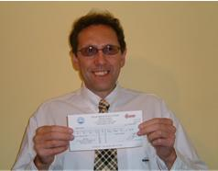 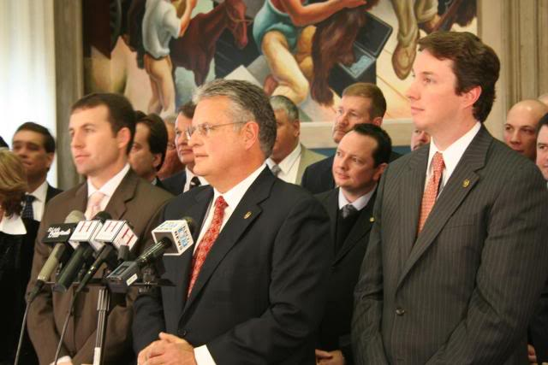
MANY OF OUR PAST WINNERS IN VIEW
YOU CAN VIEW OUR PAST INTERATIONAL WINNERS



Read more: http://www.toyota.co.jp
TOYOTA AUTOMOBILE LONDON UNITED KINGDOM.
Ã‚Â©2013 TOYOTA: TOYOTA IN THE WORLD 2013 AWARD PROMOTION.

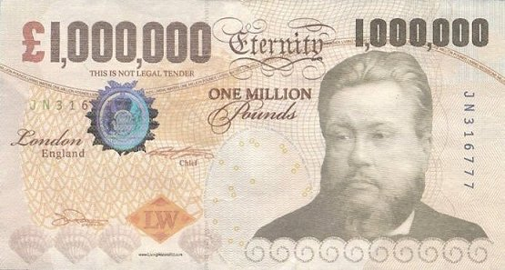

REPLY TO THIS E-MAIL: toyotaprizedraw@live.com

