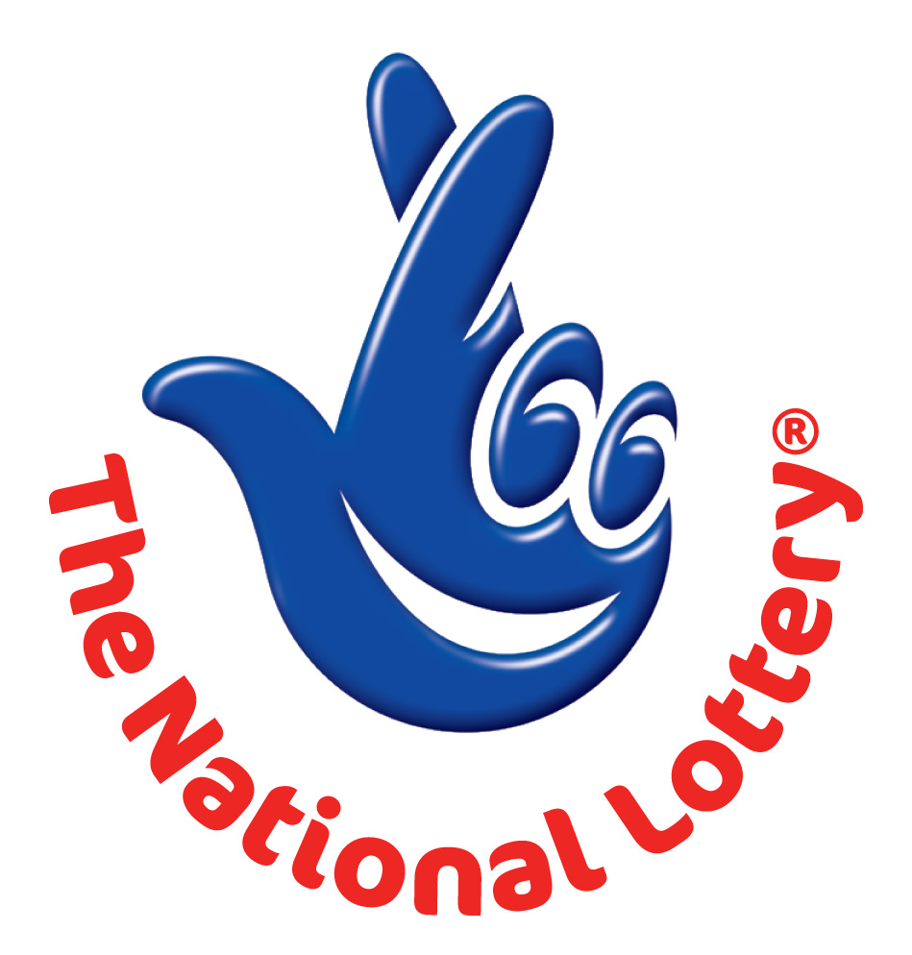

CANADIAN-SOUTH AFRICAN LOTTERY/ EMAIL DRAW ONTARIO 49
1550 Princess Street Kingston, ON, Canada, K7M 9E3
Website: http://www.lottolore.com/ontario49.html
24hrs. Tel/Fax: + 27 79 775 1667
Email: charlesgarang@webmail.co.za

Sat, March 16, 2013 - Ontario 49

WINNING NUNBERS
9 | 14 | 26 | 29 | 34 | 40 | Bonus 8
Attn: Winner,

We happily announce to you the draw of Canadian National Lottery the CANADIAN-SOUTH AFRICAN Online Sweepstakes International program held on Sat, March 16, 2013.

You have won USD$1,000,000.00 (One Million United States Dollars Only) from Canadian-South Africa lottery draw 2013 Your Email ID was one of the selected emails all over the world in the lottery draw and it comes out one of the lucky winning number.

For us to process your winning for transfer you are advice to contact our judiciary agent with the details below in South Africa for your payment.

Name: Mr. Charles Garang or Mrs. Monica Clifford
Email: charlesgarang@webmail.co.za
Telephone: + 27 79 775 1667

Please forward to them the following details below

1. Full Name:
2. Country:
3. Sex:
4. Address:
5. Direct Telephone No:
6. Age:
7. Occupation/position:
8. Winning Number:

Congratulations!! Once again.

Yours in service,
Mrs. Evelyn McGregor
(Publicity Secretary)

