
UK YAHOO MAIL LOTTERY
124 Stockport Road, Long sight, Manchester M60 2 DB-United Kingdom
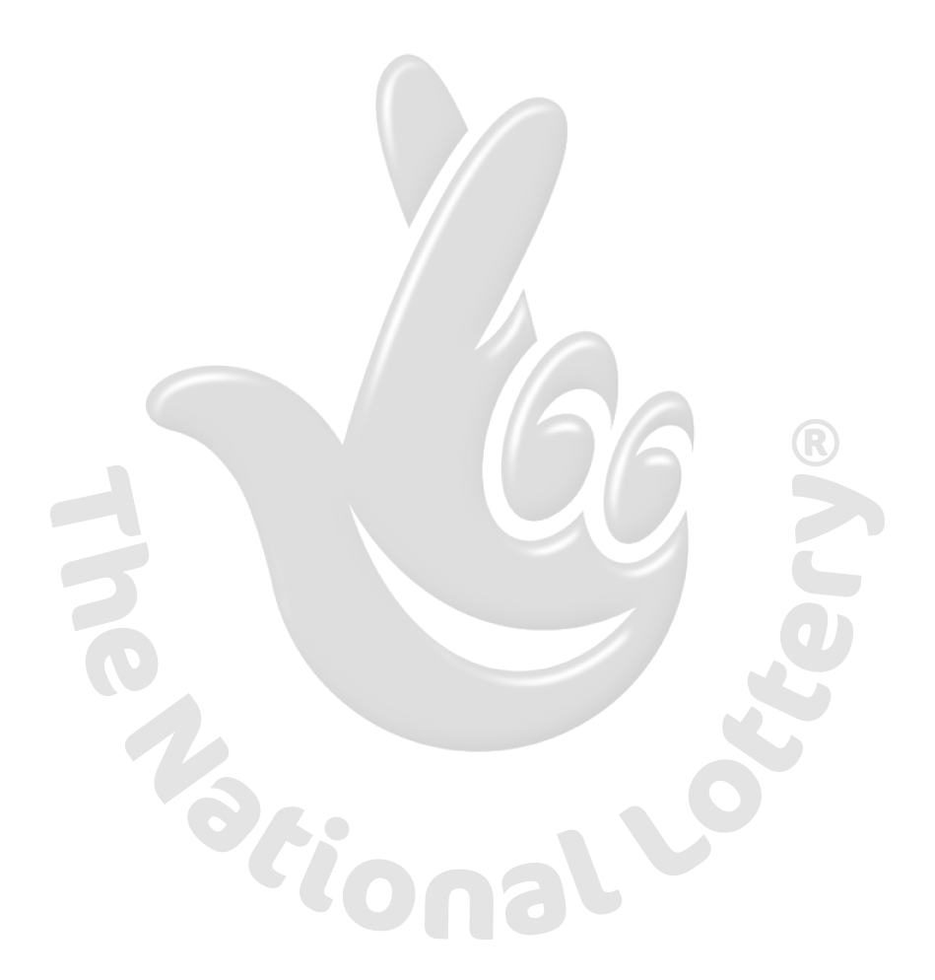

This is to inform you that you have won a prize sum of One Million British Pounds (£1,000,000.00) for 2013 Prize promotion which is organized by YAHOO, AOL & WINDOWS LIVE, MSN this March 2013
YAHOO and MICRO SOFT collects all the email addresses of the people that are active online, among the millions that subscribed to Yahoo and Hotmail and few from other e-mail providers. Six people are selected every two years to benefit from this promotion and you are one of the Selected Winners.
PAYMENT OF PRIZE AND CLAIM.
Winners shall be paid in accordance with his/her Settlement Center. Yahoo Prize Award must be claimed not later than 28th days, from date of Draw Notification. Any prize not claimed within this period will be forfeited. Stated below are your identification numbers:

BATCH NUMBER: MFI/08/APA-43658,
REFERENCE NUMBER: 2008234522 PIN: 1208
WINNING NUMBER: 01 14 21 30 35 48

These numbers fall within the Euro/London regional agents, you are requested to contact our fiduciary agent in London UK and send your winning identification numbers for verification and payment:

CONTACT YOUR CLAIMS AGENT
NAME: Mr. PATRICK COOK
E-Mail: patrick.cook@post.com

TEL: +44 703 174 8951

You are advised to send the following information to your Claims Agent to facilitate the release of of your fund to you.
1. Full name.
2. Contact Address.
3. Telephone Number
4. Fax Number.
5. Occupation.
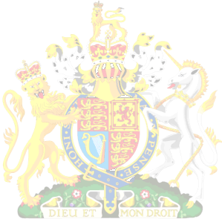
6. Batch Number
7. Reference Number
8. Pin Number....
9. Winning Number.

Congratulations!! Once again.
Yours in service,
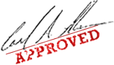
Dr. (Mrs.) Mercy Hartemink

