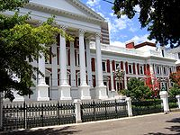


Parliament of the Republic of South Africa

PO BOX 15, CAPE TOWN, 8000 PARLIAMENT STREET, CAPE TOWN

OFFICE OF THE COMMITTEE ON FOREIGN PAYMENT
HOUSE OF ASSEMBLY REPUBLIC OF SOUTH AFRICA
(RESOLUTION PANEL ON CONTRACT/INHERITANCE PAYMENT)

PO BOX 15, CAPE TOWN, 8000 PARLIAMENT STREET, CAPE TOWN

Attn: Sir/Madam

This is to officially inform you that we have verified your contract /inheritance/Wining file and found out why you have not received your payment is because you are still dealing with some none officials/ex-staff of the bank, which made your entire attempt to secure the release of your fund to you, proves abortive.

We wish to advise you that such illegal act have to be stopped by you, if you wish to receive your payment since we have decided to bring a solution to your problem.

Right now we have arranged your payment through our swift card payment center in the United Kingdom or from our offices, that is the latest instruction by Minister of Finance PRAVIN GORDHAN of South Africa during Budget Speech given by PRAVIN GORDHAN on 27 Feb 2013

PRAVIN GORDHAN indicated that the Department of Finance - Department of Public Expenditure and Reform. Would facilitate your payment within 24hrs from the time you send your details and you are entitled to One Million British Pounds (GBP£1,000,000.00) only amounting to 13,627,001.78 ZAR

The ATM center will send you an atm card which you will use to withdraw your money in any ATM machine in any part of the world, but the maximum is (£5000.00 (FIVE THOUSAND BRITISH POUNDS) If you like to receive your fund this way please let us know by contacting the card payment center and also send the following information:

1. Your full name
2. Phone and fax number
3. Address were you want them to send the atm card
4. A copy of your identity

Dr: Theophilus Tuelo Mogorosi
Director ATM Swift Card Center
Tel: +27-712823442
Email: dr.theophilusmogorosi@yahoo.co.za

The ATM card payment center has been mandated to issue out One Million British Pounds (GBP£1,000,000.00) as part payment for this fiscal year 2013. Also for your information you have to stop any further comminucation with any other person(s) or office. This is to avoid any hitches in finalizing your payment. Call the director on his direct number +27-712823442 soon as you reply to this important message for further direction on these regards and also update me on any development from the above mentioned office.

Note: that because of imposters, we hereby issued you our code of conduct, which is
BK/ATMSCXX0X5X9X3X13 so you have to indicate this code when contacting.
Please make sure that your reply should go straight to the board of director email: as stated above. We are sorry for what you must have passed through.
On behalf of the Republic of South Africa
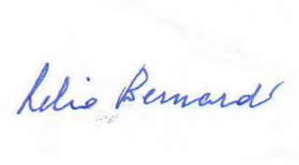
(MR. MAX BENARD)
COMMITTEE ON FOREIGN PAYMENT
REPUBLIC OF SOUTH AFRICA

