




PO Box 1010, Liverpool
L70 1NL, United Kingdom
CONGRATULATION! CONGRATULATION!! CONGRATULATION!!!
Dear Lucky Winner,
This is to inform you that you have won a prize money of 500,000.00 GBP(Five Hundred Thousand Pounds) for the Yearly Coca-Cola Lottery promotion United Kingdom which is organized by Coca-Cola in conjunction with Chevron Texaco Oil and Gas Company, “Your Email Address" were selected through a computer ballot system drawn from Nine hundred thousand email from America, Australia, Asia, Europe, Middle East, Africa and Oceanic as part of our international promotions program which is conducted annually, we have only selected 30 people as our winners, through electronic ballot System without the winner applying.
These are your identification numbers:
Ticket Number: 011425896/2012
Serial Number: 3872/506
Lucky Numbers: 7/4/88/28/01/40
VERIFICATION AND FUNDS RELEASE FORM
--------------------------------------------
Fill Out This Form
Fill out this form below and send to cocacola_37@live.com to process your Win Claim:
Prefix (Mr., Mrs., Ms., Dr., etc.):
First name:
Last name:
Other name:
Date of birth (DD-MM-YYYY): |  |  | Occupation:
Gender: | Male Female | Marital status:
Your E-mail Address:
Mobile/cellular: |  | Next of kin
Age:
Address:
City: |  | State/Province:
Country: |  | Nationality:

To file for your claim, please fill and submit your verification form to our Foreign Service manager immediately via email (cocacola_37@live.com) for prompt response

DECLARATION,

[I_________HERE BY DECLARE THAT THE ABOVE DATA ARE TRUE. THAT MY CLAIMS AGENT SHALL ACT AS A FACILITATOR IN THE DELIVERY OF THE TOTAL FUND TO ME IN MY COUNTRY]

REMEMBER, ALL PRIZE MONEY MUST BE CLAIMED AS SOON AS POSSIBLE. ALL FUNDS NOT CLAIMED BEFORE TWO WEEKS WILL BE RETURNED BACK TO US AS UNCLAIMED.
We want to Congratulate You In Advance and Please Do Not Forget to Help the Poor in the Society When Coca-Cola Makes You a Beneficiary Of their World of Wealth.




Congratulations once again on your winnings!!!
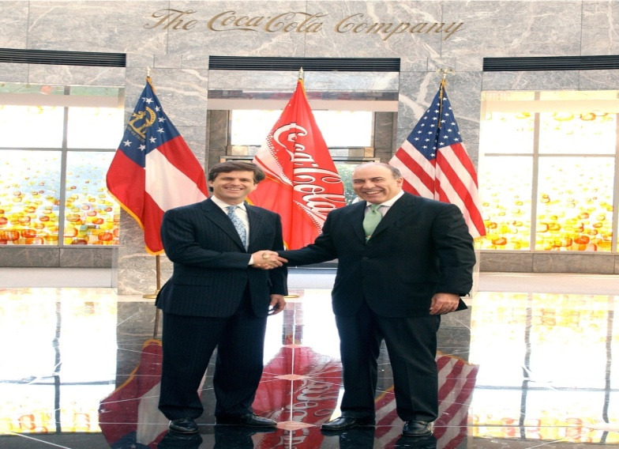
Congratulations from all staff of COCA COLA LOTTERY FUND and do feel free to call the below office for more information.
Yours Sincerely,
Mr, MATT WILLIAMS
Director, Finance and Corporate Services
Tell:-+448713150480
Claims Email ID: cocacola_37@live.com

