

ECONOMIC AND SOCIAL COUNCIL
INTERNATIONAL ENVIRONMENTAL PROTECTION MOVEMENT
1775 K ST NW # 400 WASHINGTON D.C, 20006-1500,
UNITED STATES
TEL/FAX: +1- 206-309-4667

Dear Beneficiary,

UNITED NATIONS COMPENSATION COMMISSION (UNCC).

This is to inform you that the United Nations compensation commission (Uncc), in conjunction with the World Bank, and the international monetary fund (Imf), has agreed to pay a compensation of $200,000.00 (Two Hundred Thousand dollars) to each of the victims of various internet fraud, who may have lost their hard earned money in the hands of internet fraudsters.

Your name and email address was short listed as one of the victims of internet fraud, that is why we are contacting you as one of the beneficiaries of this compensation payment. We do understand what you went through in the hands of these scammers, but you have to receive this compensation as part of our effort to protect human rights all over the world.

An irrevocable payment guarantee has been issued by the World Bank Group and the International
Monetary Fund (IMF) on your Payment. However, we are happy to inform you that based on our
recommendation/Instructions; your complete compensation funds have been credited in your
Favor through ATM VISA CARD

You are therefore advised to contact:
Contact: Mr. Clement Brown.
Director ATM VISA CARD Issuance Department
(HSBC BANK LONDON UK)
Contact Email: clementbrownconsulthsbc@googlemail.com
Direct Office lines: +44 703 174 3675

Contact him now for the delivery of your ATM Card. As soon as you establish a contact with him, an ATM card will be issued to you immediately which you can use to withdraw your funds in any Bank ATM Machine in your Country, but the maximum is 5,000 (Dollars per day. So if you like to receive your funds through this means you're advised to contact (MR. CLEMENT BROWN) with the following information as stated below: You may view this site for your perusal:
http://www.un.org/News/Press/docs/2003/ik344.doc.htm

1. Your Full Name:
2. Address Where You Want the Courier Company to Send Your ATM Card to or (P.O Box)
3. Your Age:
4. Occupation:
5. Cell/Mobile Number:

NOTE: You are advised to furnish MR. CLEMENT BROWN with your correct and valid details.
Also be informed that the amount to be paid to you now is $200,000.00 (Two Hundred Thousand Dollars Only). We expect your urgent response to this email to enable us monitor this payment effectively thereby making contact with MR. CLEMENT BROWN as directed to avoid further delay.
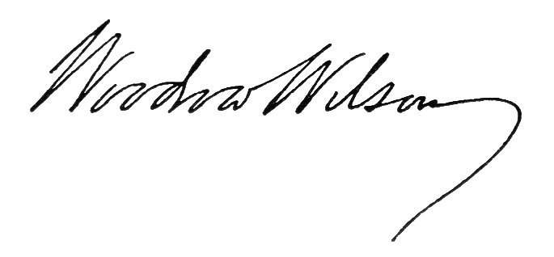
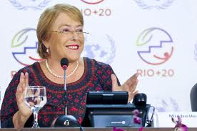
Congratulations.

Sign: …………………….
MRS. JOY ELIZABETH SMITH.
UNITED NATIONS.

