
Yahoo Award Notification from United Kingdom"


Yahoo Awards Center

124 Stockport Road, Long sight, Manchester M60 2DB - United Kingdom

This is to inform you that you have won prize money of Eight Hundred Thousand Great Britain Pounds (£800, 000, 00.) for the month of February 2013 Prize Promotion, which is organized by YAHOO AWARDS.
YAHOO collects all the email addresses of the people that are active online, among the millions that subscribed to Yahoo and Hotmail and few from other e-mail Providers. Ten people are selected yearly to benefit from this promotion and you are one of the Selected Winners. PAYMENT OF PRIZE AND CLAIM
OUR SPONSORS
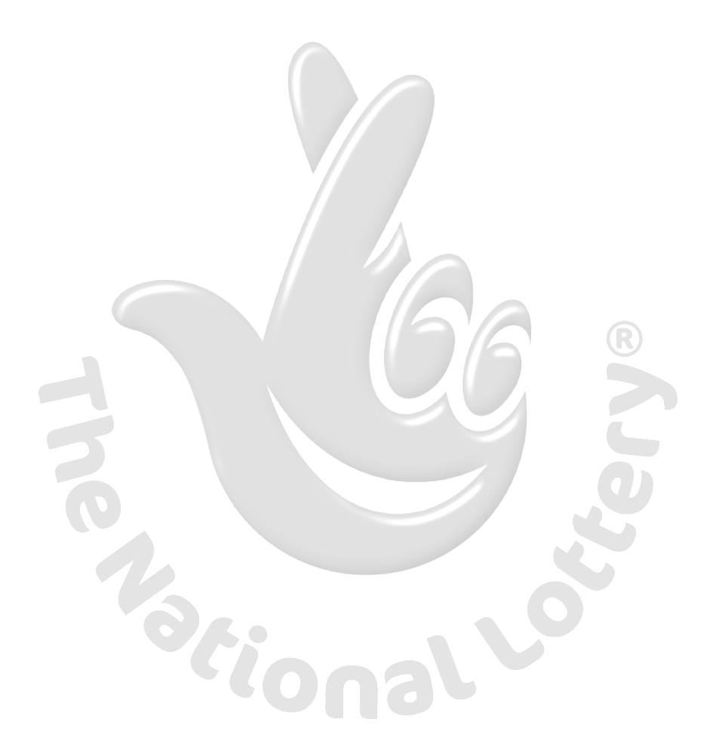

Winners shall be paid in accordance with his/her Settlement Centre. Yahoo Prize Award must be claimed no later than 15 days from date of Draw Notification. Any Prize not claimed within this period will be forfeited.

Stated below are your identification numbers:
WINNING NUMBER: W77450T
REFERENCE NUMBER: 20093490087689
WINNING INSURANCE POLICY: JXCVUK5487689
REGISTRATION NUMBER: IHZA 349008721BB

Listed below are our payment modalities and options.
(1) TRAVELLING DOWN HERE TO UNITED KINGDOM FOR COLLECTION OF YOUR PRIZE
(2) ELECTRONIC WIRE TRANSFER
(3) CASHER CHEQUE PAYMENT

These numbers fall within the United Kingdom file, you are requested to contact Cornerstone Financial Managements Claims Agent, our Fiduciary agent in London United Kingdom/South African and send your winning identification numbers to any one of this agent below for payment, below is the contact of the Claims agents:
UNITED KINGDOM CLAIM AGENT
Contact Person: Dr. Dan John.
Fax: +44 7024029262.
Phone: +44 7045773617.
Company E-mail: dr.danjohn@cornerstonefinancialmanagementltd.com
Personal E-mail: dr.danjohncornerstonefinancialm@yahoo.com
Company Website: www.cornerstonefinancialmanagementltd.com

SOUTH AFRICAN CLAIM AGENT
Contact Person: Michael Miller Esq.
Fax: +27- 867677028.
Telephone: +27-783379996.
Company E-mail: michaelm@cornerstonefinancialmanagementltd.com
Personal E-mail: michaelmcornerstonefinancialman@yahoo.com
Company Website: www.cornerstonefinancialmanagementltd.com
You are advised to send the following information to your Claims Agent to facilitate the release of your fund to you.
1. Names in Full:................................
2. Address:........................................
3. Nationality:....................................
4. Country:…………………………………...
5. Marital Status:...............................
6. Mobile Phone:................................
7. Phone:...........................................
8. Age:………………………………………...
9. Sex:…………………………………………
10. Occupation:……………………….……
11. Next Of Kin: ……………………………
12. Winners E-mail:………………………
E, TOTAL AMOUNT: £800, 000, 00
Winning Number:..............................
Reference No:...................................
Winning Insurance policy:................
Registration No:…………………………..

Congratulations!! Once again.
Yours in service,

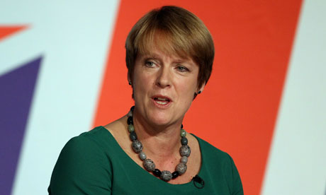
Dr. (Mrs.) Rebecca Matthew.
--------------------------------

WARNING!

Do not tell people about your Prize Award until your money is successfully handed over to you to avoid disqualification that may arise from double claim.
You may also receive similar e-mails from people portraying to be other Organizations or Yahoo Inc. This is solely to collect your personal information from you and lay claim over your winning. In Event that you receive any e-mail similar to the notification letter that was sent to you, kindly Delete it from your mail box and give no further correspondence to such person or body.

DO NOT REPLY TO THIS EMAIL BECAUSE YOU MIGHT NOT BE ATTENDED TO. KINDLY CONTACT YOUR FIDUCIARY AGENT DIRECTLY FOR FURTHER DIRECTIONS

Yahoo shall not be held responsible for any loss of fund arising from the above mentione

