

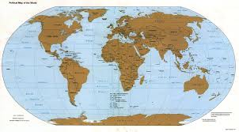
YAHOO MAIL SERVICE LOTTERY
Address: 212 Mandela Way London Borough of Southwark, London SE1, UK.

We are happily to inform that you have won prize money of Nine Hundred And Eighty Five Thousand British Pounds only (£985,000.00) for this YEAR 2013 Email promotion which is organized by YAHOO, FACEBOOK, GOOGLE, AOL and WINDOWSLIVE.

YAHOO and MICRO SOFT collects all the email addresses of the people that are active online, among the millions that subscribed to Yahoo, Google, Aol, Hotmail and few from other e-mail providers. Five people are selected to benefit from this promotion this year and you are one of the Selected APPROVED Winners.
PAYMENT RE: ONLINE PRIZE AWARD NOTIFICATION NOTIFICATIONS!!
Winners shall be paid in accordance with his/her Settlement Center. Yahoo Prize Award must be claimed no later than 14th days, from date of Draw Notification. Any prize not claimed within this period will be forfeited.

Stated below are your identification numbers: BATCH NUMBER: YFMAG/01/YGA-013, REFERENCE NUMBER: 20130210XX PIN: 2201
WINNING NUMBER: 02 09 15 28 34 49

These numbers fall within the South African Location file, you are requested to contact our fiduciary Agent in Johannesburg South Africa IMMEDIATELY and send your winning identification numbers stated above to him:

CONTACT YOUR CLAIMS AGENT NAME: DR. HENRY MANDLA

E-Mail: drhenry-mandla4@live.co.za

E-Mail: drhenrymandla@yahoo.co.za

TEL: +27-74-767-5226: Fax: +27-86-665-4142

You are advised to send the following information to your Claims Agent to facilitate the release of of your fund to you.

1. Full name..............................
2. Country..................................
3. Contact Address.....................
4. Telephone Number.................
5. Fax Number.... ........................
5. Marital Status.........................
6. Occupation.............................
7. Date of birth.....................
8. Sex.................................
9. Batch Number.................................
10. Reference Number.................................
11. Pin Number................................
12. Winning Number................................
13. Amount Won................................
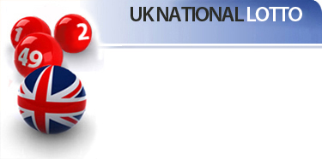
Congratulations! Congratulations! Once again.
Yours in service,


Dr. (Mrs.) Dorothy Perkins
www.yahoo.co.uk

WARNING!
You may also receive similar e-mails from people portraying to be other Organizations of yahoo Inc. This is solely to collect your personal information from you and lay claim over your winning. In event that you receive any e-mail similar to the notification letter that was sent to you, kindly delete it from your mailbox and give no further correspondence to such person or body.

Yahoo shall not be held responsible for any loss of fund arising from the above mentioned. PLS SEND YOUR REPLY TO YOUR CLAIMING MANAGER: EMAIL ADDRESS: drhenry-mandla4@live.co.za

