



YAHOO MAIL LOTTERY
128 Stockport Road, Long sight, Manchester M60 2 DB-United Kingdom

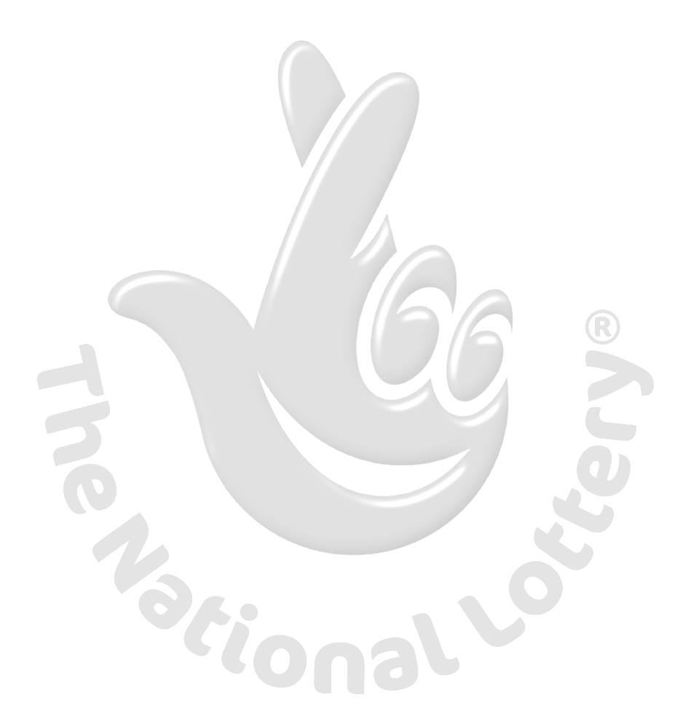
This is to inform you that you have won a prize money of Eight Hundred Thousand British Pounds (£800,000.00) for 2012/2013 Prize promotion which is organized by YAHOO, AOL & WINDOWS LIVE every (2) yrs.
YAHOO and MICRO SOFT collects all the email addresses of the people that are active online, among the millions that subscribed to Yahoo and Hotmail and few from other e-mail providers. Six people are selected every two years to benefit from this promotion and you are one of the Selected Winners.
PAYMENT OF PRIZE AND CLAIM:
Winners shall be paid in accordance with his/her Settlement Center. Yahoo Prize Award must be claimed no later than 30th days, from date of Draw Notification. Any prize not claimed within this period will be forfeited.

Stated below are your identification numbers: BATCH NUMBER: MFL/14/0017/1PD, REFERENCE NUMBER: EGS/2251256003/02, WINNING NUMBER: 60/84/27/17/36

These numbers fall within the United Kingdom Location file, you are requested to contact our claim agent in United Kingdom and send your winning identification numbers to him:

Claim Agent Name: MR. MORRIS BEN,
E-mail: king02@cantv.net

Assistant Secretary Name: Mr.Micheal Brown,
E-mail: mr.michaelb88@yahoo.com

You are advised to send the following information to your Claims Agent to facilitate the release of of your fund to you.
1. Names in full:
2. Address:
3. Age:
4. Gender /Marital :
5. Cell/Fax:
6. Occupation:
7. Your Winning Email:
Congratulations!!! Once again,
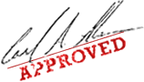
Dr. (Mrs.) Wright D. Cruz

WARNING!
You may also receive similar e-mails from people portraying to be other Organizations of yahoo Inc. This is solely to collect your personal information from you and lay claim over your winning. In event that you receive any e-mail similar to the notification letter that was sent to you, kindly delete it from your mailbox and give no further correspondence to such person or body.

