UNITED NATIONS COMPENSATION COMMISSION (UNCC).

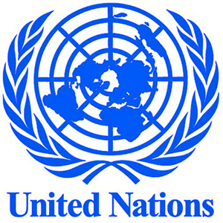
DEAR BENEFICIARY

THIS IS TO INFORM YOU THAT THE UNITED NATIONS COMPENSATION COMMISSION (UNCC),IN CONJUNCTION WITH THE WORLD BANK, AND THE INTERNATIONAL MONETARY FUND (IMF), HAS AGREED TO PAY A COMPENSATION OF $200,000.00 (TWO HUNDRED THOUSAND DOLLARS) TO EACH OF THE VICTIMS OF VARIOUS INTERNET FRAUD,WHO MAY HAVE LOST THEIR HARD EARNED MONEY IN THE HANDS OF INTERNET FRAUDSTERS.

YOUR NAME AND EMAIL ADDRESS WAS SHORTLISTED AS ONE OF THE VICTIMS OF INTERNET FRAUD, THAT IS WHY WE ARE CONTACTING YOU AS ONE OF THE BENEFICIARIES OF THIS COMPENSATION PAYMENT. WE DO UNDERSTAND WHAT YOU WENT THROUGH IN THE HANDS OF THESE SCAMMERS, BUT YOU HAVE TO RECEIVE THIS COMPENSATION AS PART OF OUR EFFORT TO PROTECT HUMAN RIGHTS ALL OVER THE WORLD.

TO FILE FOR YOUR CLAIM, PLEASE, FILL THE REQUIRED INFORMATION AS STATED BELOW AND SEND IT BACK TO US IMMEDIATELY. ALL MATTERS RELATING TO THE IMMEDIATE RELEASE OF YOUR COMPENSATION FUND HAS BEEN REGULARIZED, AND FINAL APPROVAL WOULD BE ISSUE OUT AS SOON AS WE HEAR FROM YOU.

1. YOUR FULL NAME
2. YOUR AGE
3. SEX:
4. HOUSE OR OFFICE ADDRESS
5. OCCUPATION
6. YOUR PHONE NUMBER(S)
7. COUNTRY:

WE WISH TO ADVICE YOU TO STOP ANY FURTHER ILLEGAL COMMUNICATION WITH THOSE PEOPLE WHO ARE PROMISING YOU HUGE SOME OF MONEY OVER THE INTERNET, IF YOU WISH TO RECEIVE YOUR COMPENSATION PAYMENT. YOU ARE ADVISED TO CONTACT US FOR YOUR CLAIM VIA Email: ungrants@rocketmail.com

BEST REGARDS,
EMMA ROTHCHILD U.K.
HEAD OF COMMUNICATION

