




YAHOO & FACEBOOK AWARDS CENTER.
BRITISH MICROSOFT IN-CONJUNCTION WITH FACEBOOK AWARD
HEADQUARTERS: CUSTOMER SERVICE 44 KING CHARLES STREET CITY OF WESTMINSTER.
DEAR WINNER

Your email addresses have just won YAHOO & WINDOWS LIVE, IN-CONJUNCTION WITH FACEBOOK AWARD prize money of (SEVEN HUNDRED & FIFTY THOUSAND GREAT BRITAIN POUNDS) (£750,000.00 GBP) On Monday, 10th December 2012 Award winners emerge through random selection of all active email subscribers and facebook online users. Seven are selected monthly to benefit from this promotion.

PRIZE CLAIM PROCEDURE
Winners are to be paid in accordance with his/her Settlement Center. This Prize Award must be claimed not later than 15 working days from date of draw notification after which unclaimed prizes are cancelled.

These are your identification numbers:
Reference Number: FACEBOOK/YWL/004/055
Batch Number: YWL/YAHOO/FACEBOOK/025
Award Organizing File Code: UK/YWL/FACEBOOK
These numbers fall within the South African file. Thus, you are requested to contact our fiduciary agent in Johannesburg South Africa and send your winning identification numbers to him:

CONTACT INFORMATION OF YOUR RELEASING MANAGER IN SOUTH AFRICA.
NAME: MRS. SYLVIA PIETERSE
TELEPHONE: +27 792883268
FAX NUMBER: +27 867501027
E-MAIL:sylviapieterse2012@hotmail.com

Kindly send the following information to your claim agent to facilitate the release of your fund.
1. Full Names:……………………………………………………………………………
2. Country of Residence…………………….Nationality:………………………
3. Mobile:………………………….Telephone Number:…………………………..
4. Fax Number: ………………………………………………………………………….
5. Gender:………………………….Winning Email:…………………………………
6. Date of Birth:………………………… Marital Status…………………………..
7. Full Address:……………………………………………………………………………
8. Your Company Name:……………………………………………………………….
9. Occupation:……………………………………………………………………………..
Once your Releasing Manager acknowledges the receipt of the above request details, he will get back to you immediately with the modalities on how the release should be made.


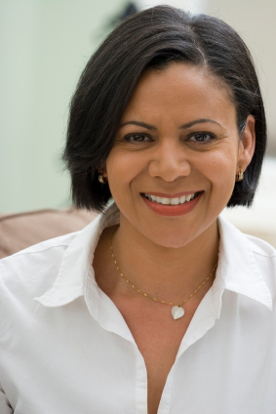
CONGRATULATIONS!! ONCE AGAIN!
YOURS IN SERVICE,

[MRS. GRACE CHURCH]
[MRS. SYLVIA PIETERSE]
[PROF. PASCAL HOLMES] [AWARD AMIN. SECRETARY]
[RELEASING MANAGER] LOTTERY BOARD DIRECTOR HEAD OFFICE U.K
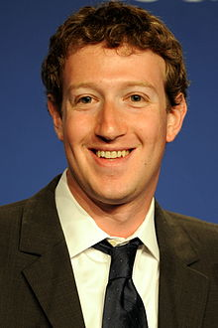
NOTE
You are hereby advised not to disclose the content of this Prize Award to anybody, until your prize money have been remitted to you to avoid disqualification that will arise from dual claim.

(MR. MARK ELLIOT ZUCKERBERG)
CHAIRMAN AND CEO OF FACEBOOK

