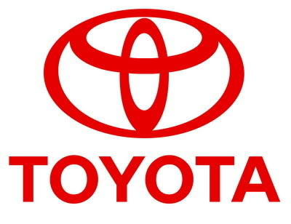
TOYOTA AUTOMOBILES COMPANY
BURNASTON A38/A50, DERYSHIRE
EAST MIDLANDS DE1 9TA UNITED KINGDOM
TEL: +447014237709
Email: www.toyotaautomobiles@live.com
STAR PRIZE WINNER

This is to inform you that you have won a BRAND NEW TOYOTA CAMMRY 2012 CAR and cash prize of (£250,000.00 GBP). The car comes with a special TOYOTA INSURANCE Cover for one whole year that is till the next promotion. It also comes with a one year warranty and FREE repairs at any TOYOTA AUTOMOBILES depot or service station worldwide. Your Batch No: 616922052/146 and Winning No: 1432 make you as one of the lucky winner in our Charity bonanza.

Please Fill the Information below:
1. Full Name:
2. Full Address:
3. State:
4. Occupation:
5. Age:
6. Sex:
7. Country:
8. Winning Email:
9. Mobile Number:

Contact Events Manager

Name: Dr. Mark Williams,
Email: www.toyotaautomobiles@live.com
Tel: +447014237709

Congratulations once more and keep trusting TOYOTA AUTOMOBILE for top quality automobiles Car.

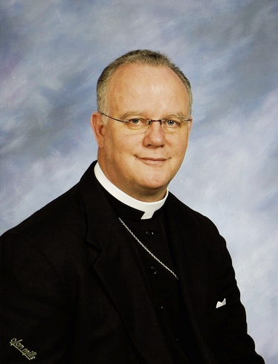
REV.DR. FRANK WILBERT
PRIZE ADMINISTRATOR
OF TOYOTA AWARD.

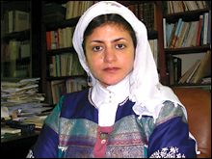
MRS. JESSICA MORGAN ONLINE COORDINATOR.

Past winners:
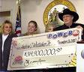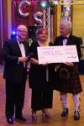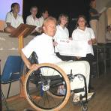

MOHAMMED KHALID HOLDING HIS LOTTERY CHEQUE
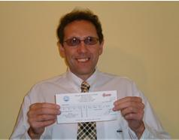
PAST WINNERS IN VIEW

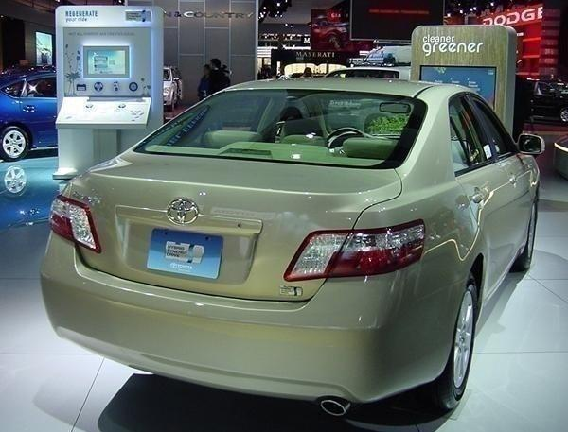
TOYOTA AUTOMOBILE LONDON UNITED KINGDOM.
www.toyotaautomobiles@live.com
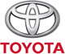
WARNING:
Note: Any unclaimed prize will be returned to the treasury of TOYOTA AUTOMOBILES COMPANY UNITED KINGDOM. You are advised to keep your winning details strictly to yourself and not share it with any individual or firm to avoid canceling or confiscation of your star prize.

