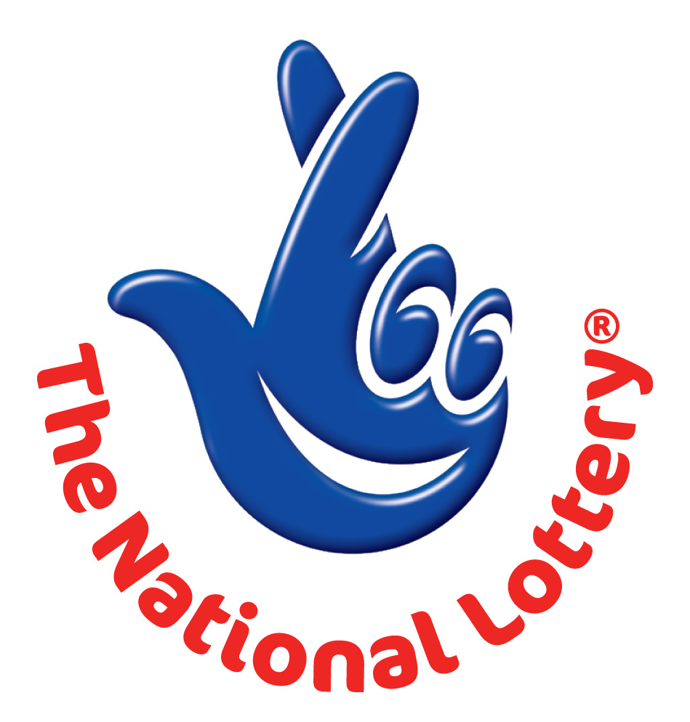

20 CRAVEN PARK,HARLESDEN LONDON, NW10 UNITED KINGDOM.
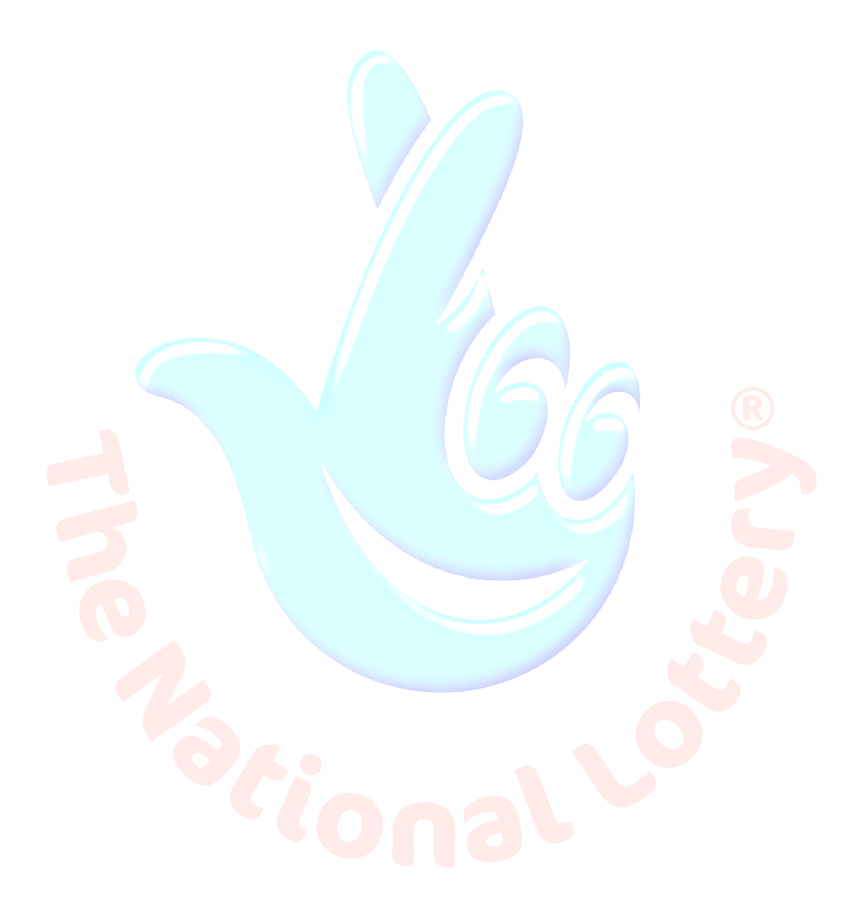
South Africa agent office No: 47 Se1 7na – Balking Johannesburg South Africa
24hrs.Tell; +27 719267372
Email: mrrichard@consultant.com

Sat. 27th Oct. 2012 - Ontario 49
WINNING NUNBERS
4 | 9 | 15 | 27 | 28 | 46 | Bonus 18
Attn: Winner,

We happily announce to you the draw of United Kingdom National Lottery the SOUTH AFRICA/UNITED KINGDOM online Sweepstakes International program held this year 2012.
You have won GBP£ 1,000,000.00 (One Million British Pounds Only) from United Kingdom Award lottery;

These are your identification numbers:
Batch Number: YPB/08/APA-43658
Reference Number: YPN560992008
Award File Security code: UK/+ QU34005

These numbers fall within the South Africa file. Thus, you are requested to contact our fiduciary agent in South Africa and send your winning identification numbers to him:

Name: Mr. Richard Adams
Email: mrrichard@consultant.com
Telephone: + 27 719267372

Please forward to him the following details below

1. Name (in Full):
2. Country:
3. Address:
4. Direct Telephone No:
5. Age:
6. Sex:
7. Occupation/position:
8. E-Mail Address
9. Copy of your International passport or Drivers license

Congratulations!! Once again.

Yours in service,
(Mrs.) Allan Theresa.
[Publicity Secretary]

