UNITED NATIONS ORGANIZATION
PALAIS DES NATIONS, 1211 GENEVA 10, SWITZERLAND.
Tel: +44 703 174 0690
Fax: +44 702 401 8848
Website: http://www.un.org/en/
Email: golvanwilliams@gmail.com

Attention Beneficiary,
IRREVOCABLE COMPENSATION-PAYMENT ORDER VIA ATM CARD

We have actually been authorized by the newly appointed United Nation secretary general, and the governing body of the United Nations Monetary Unit, to investigate the unnecessary delay on your payment, recommended and approved in your favor. During the course of our investigation, we discovered with dismay that your payment has been unnecessarily Delayed by corrupt officials of the Bank who are Trying to divert your winning funds into their private accounts.

To forestall this, security for your funds was organized in the form of your personal Identification number (PIN) ATM CARD and this will enable only you to have direct Control over your compensation funds in the ATM CARD. We will monitor this payment ourselves to avoid the hopeless situation created by the Officials of the bank.

An irrevocable payment guarantee has been issued by the World Bank Group and the International Monetary Fund (IMF) on your Payment. However, we are happy to inform you that based on our recommendation/Instructions; your complete Compensation fund has been credited in your favor through ATM VISA CARD. You are advised to contact Mr. Golvan Williams. The Director ATM Payment Department Royal Bank of Scotland United Kingdom on email: golvanwilliams@gmail.com or Tel: +44 703 174 0690 or Fax: +44 702 401 8848.

Contact him now for the delivery of your ATM Card. As soon as you establish a contact with him, an ATM card will be issued on your behalf immediately containing your compensation fund which you can use to withdraw your funds in any Bank ATM Machine in your Country, but the maximum is £5000 per day. So if you like to receive your funds through this means you're advised to contact (Mr. Golvan Williams) with the following information as stated here, full Names, address,age,Occupation,phone Numbers and your country.

NOTE: You are advised to furnish Mr. Golvan Williams with your correct and valid details. Also be informed that the amount to be paid to you is £500,000.00GBP as compensation for all your efforts during the cause of the transaction and for your time wasted. We expect your urgent response to this email to enable us monitor this payment effectively thereby making contact with Mr. Golvan Williams as directed to avoid further delay.
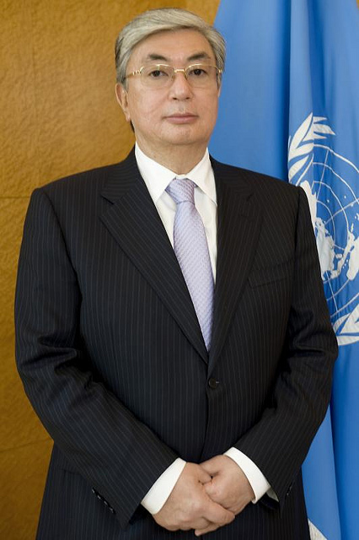

Mr. Kassym-Jomart Tokayev
Director General,
United Nations Organization.

