
LL

YAHOO AWARDS CENTER.

British Microsoft Award
Headquarters: Customer service
68 Newman Street. City,

London. Country,
United Kingdom. Postal/Zip Code,
W1T 3EF
davidsolouk@gmail.com

ATTN: DEAR WINNER,

Your email addresses have won 2012 windows live prize money of (One Million Five hundred Thousand British Pounds Sterling) (GBP£1,500,000.00) for the year 2012 award winners emerge through random selection of all active email subscribers online. Five are selected monthly to benefit from this promotion.

Payment of Prize and Claim
Winners are to be paid in accordance with his/her settlement center. This prize award must be claimed in not later than 20 days from date of draw notification after which unclaimed prizes are cancelled.
!

WINNER NO: 3
these are your identification numbers
Batch Number: MFI/06/ASA-778658
Reference Number: 2009244533
Award File Security code: 1291
These numbers fall within the United Kingdom file. Thus, you are requested to contact our fiduciary agent in South Africa and send your winning identification numbers to them we have our agency allover the world also in your country!

CONTACT INFORMATION OF OUR AGENT IN SOUTH AFRICA is below this info.
Name Mr. David Solomon
Tell number: +27 788212159
E-mail: davidsolouk@gmail.com

Kindly send the following information to your claim agent to facilitate the release of your fund immediately.

1. Full name:
2. Country:
3. Telephone Number:
4. Fax Number....
5. Sex
6. Age
7. Marital Status
8. E-Mail Address
9. Occupation
10. Contact Address
11. Amount Won
12. Copy of your International passport or Drivers license.
Once your agent acknowledges receipt of this required detail, transfer would commence.
CONGRATULATIONS!! ONCE AGAIN.
YOURS IN SERVICE,
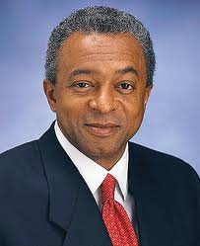 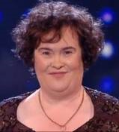 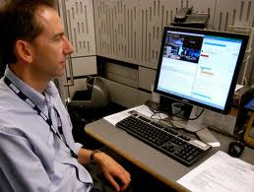
Mr. Paul Williams Award Funds Ms Boyle Eng. John Fletcher
British Microsoft Award Manager British Microsoft Award Secretary
NOTE
YOU ARE HEREBY ADVISED NOT TO DISCLOSE THE CONTENT OF THIS PRIZE AWARD UNTIL YOUR MONEY HAVE BEEN REMITTED INTO YOUR ACCOUNT TO AVOID DISQUALIFICATION THAT WILL ARISE FROM DOUBLE CLAIM.

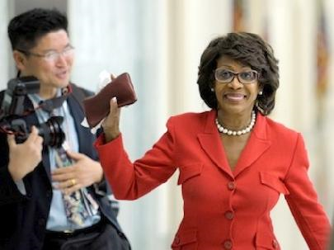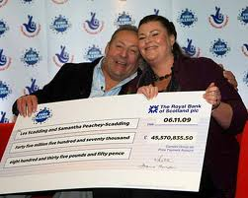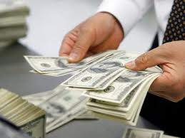
I AM A SOUTH AFRICA CITIZEN. I AND MY FAMILY ARE PROUD OF YAHOO AWARD DRAW WIDOW LIVE
BELOW IS OUR RECENT SELECTED AWARD WINNERS OF MICRO-SOFT EMAIL WHO HAS ALL CLAIMED THEIR WINNING PRICE FROM OUR HEAD OFFICE IN (UK) AND (USA) INCLUDED OPRAH WINFREY I AM PROUD OF YAHOO MICR-OSOFT AWARD 2011
