
neso



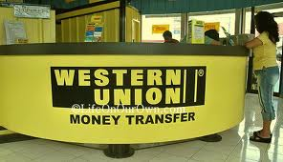YOU’RE WINNING FILE NUMBER/Uk/2012

A Division of Financial Service Provider

Dear Sir/Madam
We are making our 158th Anniversary to the beginning of the year 2012; we rolled out over USD$16, 000, 000, 00 (Sixteen Million United State Dollars) for our 158th Anniversary draws. All participants were selected through computer ballot system drawn from 25,000,00 company email address, and 30,000,00 individual email address from over 40 networks from Australia, new Zealand, North America, South America, Europe, all Asia and Africa as part of International promotion held in 135 Queen Victoria Street London EC4V 4AA.

We officially announce to you that your email address has just won the sum of USD$600, 000. 00 (Six Hundred Thousand United State Dollars). To begin the verification process of your prize; you are to forward your winning details to.
The Claim Transferring Agent Contact Details as Fellows;
NAME: MR. FRANCISCO DAVIN
TEL: +44 75523 23346
FAX: +44 7092 890 713
EMAIL:francisco.davin@hotmail.co.uk

You should establish contact with redeeming transferring manager via email or telephone with the particulars presented below for immediate payment to your bank account; please remember to quote your winning file number and your winning transferring identification code in your correspondence to him.
1. Full Name:
2. Address
3. Your Mobile Telephone Number
4. Date of Birth
5. Occupations
6. Countries
7. Sex
8. Postal Code

You will be contacted by western union transferring manager in the nest 24hours as soon as you forward required information to him for the transfer.

Save time, send money, earn rewards! Western Union is a service people trust.

ANNIVERSARY DAY:

YOU’RE WINING TRANSFER IDENTIFICATION CODE WUNT 688/765/UK
70126841 098267265211

Thank you for using Western Union!

