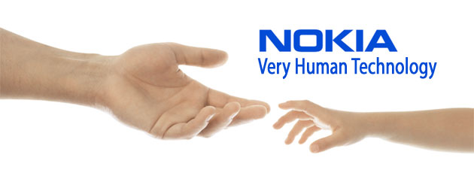
NOKIA UK PROMOTION
42 Park Avenue,
Barbourne, Worcester, United Kingdom.
File No: NOKIA/UK/407/PROMO/2012
E_mail: nokiaclaims@acmilan-shqip.org
CONGRATULATIONS!!! CONGRATULATIONS!!! NOKIA UK PROMOTIONS!!! IF YOU HAVE RECIEVED THIS MESSAGE, PLEASE CALL: Tel: +447017045742AND FOLLOW ALL INSTRUCTIONS CAREFULLY AS DIRECTED.
Dear Winner,

In line with the commemorating event marking our anual anniversary of the NOKIA MOBILE TELECOMMUNICATION, we rolled out over £500,000.00 GBP (five thousand Great Britain Pounds) for our anual Anniversary Draws. Winner are selected through a raffle draw conducted on active Email I.D from our subscribing networks worldwide and a REF NUMBER is assigned to all winning Email I.D.your Email address has just won for you
the sum of (500,000.00GBP) Five Hundred Thousand Pounds Sterling, Along with Nokia E7 Smartphone]
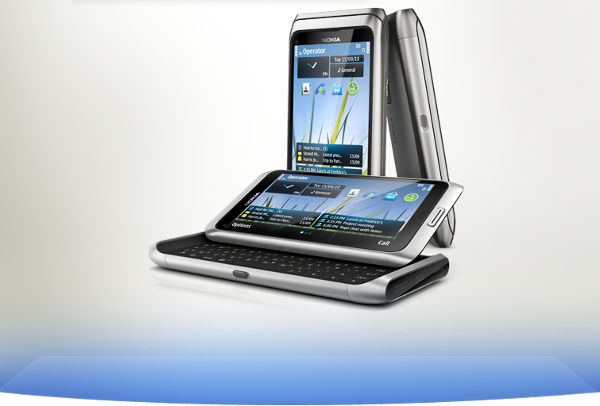
This promo is approved by the British Gaming Board and also licensed by the International Association of Gaming Regulators (IAGR). This promo is the 1st of its kind and we intend to sensitize the public. To begin the verification process of your prize, you are required to fill the below verification requirements and send a (scan copy of your International Passport, Drivers License or Pan Card for identification.)
Ref Number: ...........XYL /26510460037/05
Batch Number: ................24/00319/IPD
Winning Number:.......................YM/09788
VERIFICATION REQUIREMENT FORM
How ever you will have to fill and submit this form to the events manager
1. Full names:
2.Contact Address
3.Age:
4.Sex:
5.Occupation:
6.State:
7.Country:
8.Telephone Number:
9.Amount Won:
10 your email:
11 Delivery Option:

E-MAIL YOUR BANK DETAILS FOR PAYMENT
1. Account No:
2. Account Name:
3. Bank Name:
4. Bank Branch:
5. E-MAIL ADDRESS:
6. MOBILE NUMBER:

CONTACT EVENTS MANAGER
NAME: Mr JEFF HALL,
TEL+447017045742
Reply To This I.D: nokiaclaims@acmilan-shqip.org

Congratulations from all members and staff of nokia UK promo.
Yours faithfully,
Mrs Pat Johnson
Online coordinator (Sweepstakes International Program).
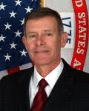 Mr. JEFF HALL Mrs. Pat Johnson

Nokia
Nokia, Finnish Rubber Works Ltd.

