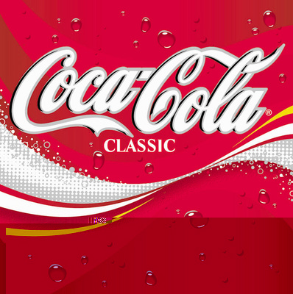

THE COCA COLA COMPANY PROMOTION/PRIZE AWARD DEPT.
COCA COLA AVENUE STAMFORD BRIDGE LONDON. SW1V 3DW UNITED KINGDOM 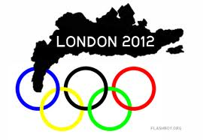
ATTENTION: WINNER,
COCA COLA COMPANY AND 2012 OLYMPIC OFFICIAL AWARD NOTIFICATION
We are pleased to inform you of the result of just concluded 2012 draws held on the 25th July, 2012 by Coca-Cola Company in conjunction with the Olympic Organizing Promotion committee London, United Kingdom , your email was among the 10 Lucky winners who won One Million British Pounds (£1,000,000.00) each on the COCACOLA COMPANY AND OLYMPIC LOTTO AWARD PROMOTION.

However the results were released on the (August 6th 2012) and your email attached to ticket number (2PYUK2010) and ballot number (UK: 51322010/110) were among the lucky winners. The online draws was conducted by a random selection of email addresses from an exclusive list of 29,031 E-mail addresses of individuals and corporate bodies picked by an advanced automated random computer search from the internet. However, no tickets were sold but all email addresses were assigned to different ticket numbers for representation and privacy. This Lottery is approved by the British Gambling Board and also Licensed by the International Association of Gambling Regulators (IAGR).This is the 3rd of its kind and we intend to sensitize the public.

This is in appreciation to our customers’ world wide for their support in the 2012 OLYMPIC GAMES IN LONDON and to seek your support in the 2014 FIFA world cup in Brazil. COCA COLA IS THE OFFICIAL DRINK IN THE 2012 OLYMPIC GAMES IN LONDON. In other to claim your £1,000,000.00 prize winning which has been deposited with our paying bank.
PAYMENT PRIZE AND CLAIM
Winners shall be paid in accordance with his/her Settlement Centre. Coca Cola Prize Award must be claimed no later than 60 days from the date of Draw Notification. Any Prize not claimed within this period will be forfeited.

You are requested to contact our fiduciary agent in London and send your winning details to him;
(CONTACT CLAIM AGENT) NAME: MR. SMITH OTIS
E-mail: smithatotisagent@consultant.com Tel: +44 703 174 3597
You are advised to send the following information to your agent to facilitate the release of your winning fund to you.
(1) NAME:.....................................
(2) AGE:........................................
(3) SEX:....................................... .
(4) ADDRESS:..............................
(5) EMAIL:....................................
(6) PHONE:..................................
(7) OCCUPATION:.......................
(8) COMPANY…………………….
(9) STATE/CITY:.........................
(10)COUNTRY:................................
(11) NATIONALITY:........................
(12)TICKET / BALLOT NUMBER:………
(13)AMOUNT WON: ………………
Congratulations Once again!
Yours in service
Mrs. Linda Dominic.

WARNING!!
Do not tell people about your Prize Award until your money is successfully handed over to you to avoid disqualification that may arise from double claim. You may also receive similar e-mails from people portraying to be other Organizations or Coca-Cola Company. This is solely to collect your personal information from you and lay claim over your winning. In event that you receive any e-mail similar to this notification letter that was sent to you, kindly delete it from your mail box and give no further correspondence to such person or body. Coca-Cola shall not be held responsible for any loss of fund arising from the above mentioned.

