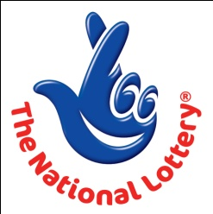
CANADA LOTTERY/ EMAIL DRAW ONTARIO 49
1550 Princess Street Kingston, ON, Canada, K7M 9E3

The U.K National Lottery

12 Bridge Street, Staines Middlesex TW18 4TP
United Kingdom.
FROM: THE DESK OF THE VICE PRESIDENT.

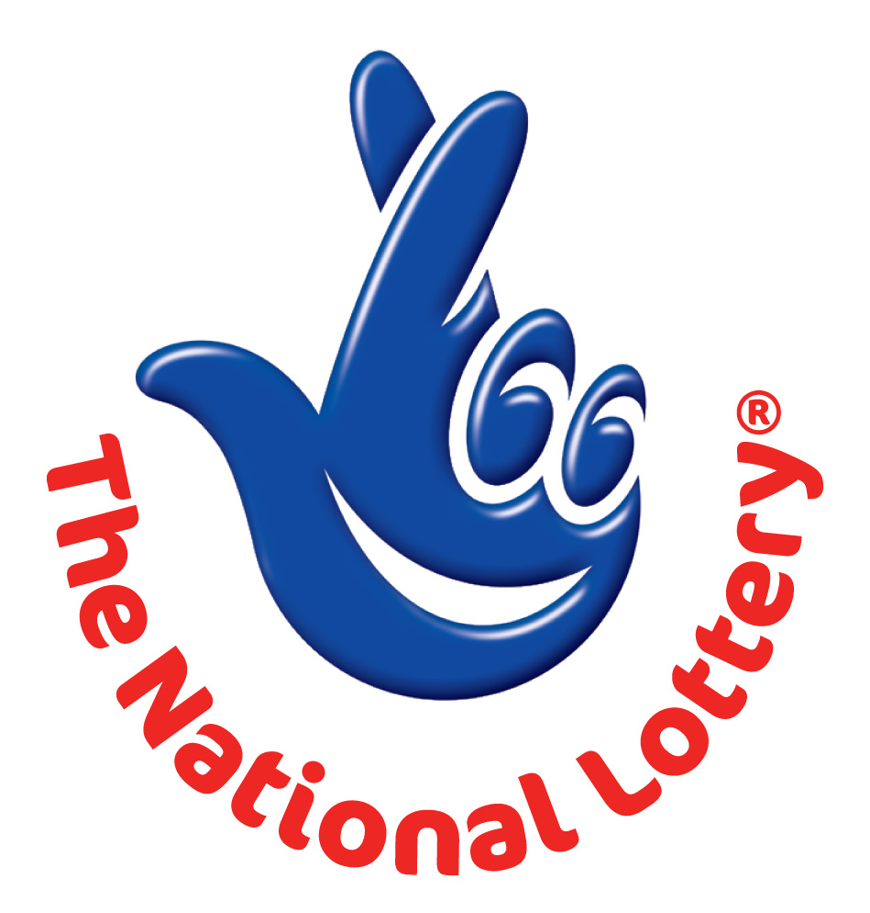
BATCH: EGS/ 22504002/03: REFERENCE: 15/0018/IPD
EMAIL: claimprize20@gmail.com

MAY 2012- Ontario 49 LATEST Draw

WINNING NUNBERS
10 | 25 | 39 | 44 | 47 | 48 | Bonus 2

Attn: Winner,

We happily announce to you the draw of Canadian National Lottery the UK/CANADA online Sweepstakes International program held this month of MAY 2012.

You have won USD$1,000,000.00 (One Million United States Dollars Only) from Canadian lottery draw 2012.
Your Email ID was one of the selected emails all over the world in the lottery draw and it comes out one of the lucky winning number.

For us to process your winning for transfer you are advice to contact our judiciary agent with the details below in London for your payment.

Name: MR.BRIGHT TAHIR
Email: claimprize20@gmail.com
Telephone: +44 703 174 8691
Fax: + 44 870 471 7855

Please provide the following details for processing of your claim.

VERIFICATION FORM
1,FULL NAME:
2, FULL ADDRESS:
3, NATIONALITY:
4, SEX:
5, AGE:
6, PHONE/MOBILE:
7, FAX
8, OCCUPATION:
9, COMPANY
10, AMOUNT WON:
11, WINNING NUMBER:
12, BATCH NUMBER:
13, EMAIL ADDRESS:
14, REFERENCE NUMBER:

UK/CANADA LOTTERY PROMOTION FORM

Congratulations!! Once again.

Yours in service,
Mrs. Evelyn McGregor
[Publicity Secretary]

