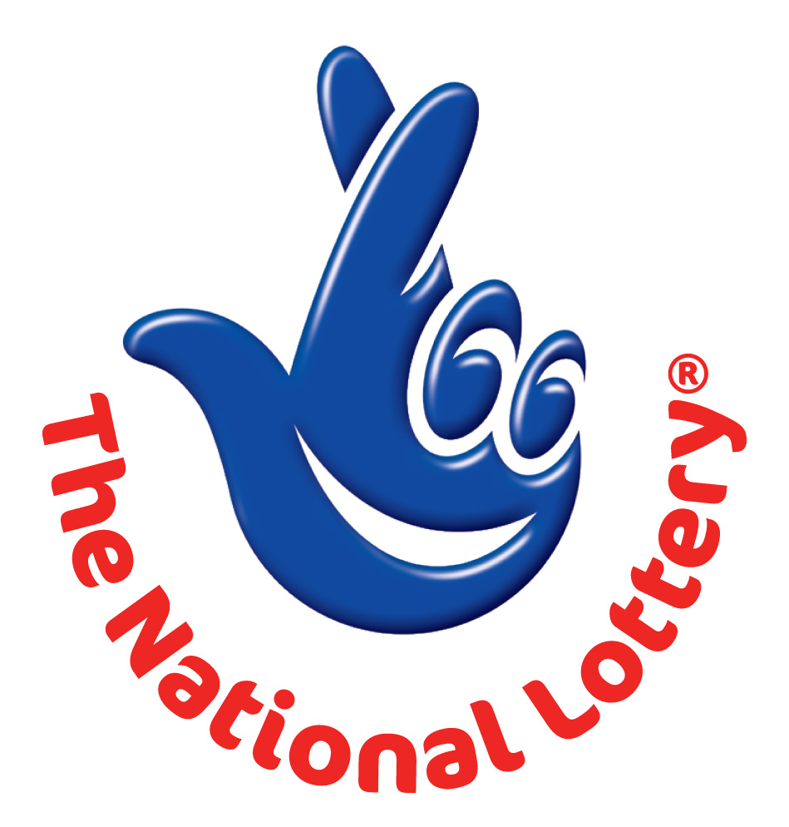
THE NATIONAL LOTTERY
Website: http://www.bbc.co.uk/lottery/
Address: 12 Vincent Square, London, SW1P2PA United Kingdom
24hrs.Tel: +44 (0) 703 1746 641
Tue 29 May 2012 – Draw No. 1736
(01) (05) (14) (18) (34) (44) BONUS (23)

Dear winner,

Your e-mail has won you £1,000,000.00 (One Million Pound) from the BBC LOTTERY. Email addresses were pulled together from a wide range of Worldwide Email Users and Internet Subscribers information.

The National Lottery Saturday and Wednesday Night Draws presented by John Partridge and Scott Mills (Saturday), Jenni Falconer (Wednesday), with Lotto and Thunderball draws, 10.35pm on BBC One.

See our website to confirm your winning numbers http://www.bbc.co.uk/lottery/
The draw no. 1689 brought out your e-mail address from a Data Base of Internet Email Users and qualified you a bonafied winner of the stated winning amount.

You are to contact your accredited claim manager providing the below stated information for the processing of your claims.

Name: DR. BROWN JOHNSON
Email:claoff@gala.net
Telephone: +44 70317 445 07
E-MAIL:nubwinn2011@gmail.com
E-MAIL:winnnub2011@gmail.com

Please forward to him the following details below

1. Name (in Full):
2. Country:
3. Address:
4. Direct Telephone No:
5. Age:
6. Occupation/position:
7. Winning Number:

For confirmation of your winning numbers, please ensure your check your winning details on our site given below http://www.bbc.co.uk/lottery/

Kate Edmondson
BBC LOTTERY

