

ECONOMIC AND SOCIAL COUNCIL
INTERNATIONAL ENVIRONMENTAL PROTECTION MOVEMENT
1775 K ST NW # 400 WASHINGTON D.C, 20006-1500,
UNITED STATES
TEL/FAX: +1-206-202-1160

Dear Beneficiary,

Irrevocable Payment Order
We have actually been authorized by the newly appointed United Nation secretary general, and the governing body of the UNITED NATIONS Monetary Unit, to investigate the unnecessary delay on your payment, recommended and approved in your favor. During the course of our investigation, we discovered with dismay that your payment has been unnecessarily Delayed by corrupt officials of the Bank who are Trying to divert your funds into their private accounts.

To forestall this, security for your funds was organized in the form of your personal Identification number (PIN) and this will enable only you to have direct Control over your funds. The pin number is 82075. We will monitor this payment ourselves to avoid the hopeless situation created by the Officials of the bank.

An irrevocable payment guarantee has been issued by the World Bank Group and the International Monetary Fund (IMF) on your Payment. However, we are happy to inform you that based on our recommendation/Instructions; your complete Winning/Inheritance funds will be credited in your favor as soon as you respond to this email. Your pin code is 82075

You are therefore advised to contact:

Mr. Andre Smith.
Certified Associate of Goldratt Institute
62 Abingdon Road EX20 9QB London, England
Contact Email: andresmith3@london.com
Call: +44 702 408 5699
Tell: +44 703 591 7368
Fax: +44 704 308 3276

Contact him now for the transfer of your fund. As soon as you establish a contact with him, he will forward your details to the bank which is being monitored by us. Therefore you are advised to contact (MR. ANDRE SMITH) with the following information as stated below:

1. Your Full Name:
2. Address:
3. Your Age:
4. Sex
5. Pin Code:
6. Occupation:
7. Cell/Mobile Number:

NOTE: You are advised to furnish MR. ANDRE SMITH with your correct and valid details. Also be informed that the amount to be paid to you is One Million Great British Pounds Sterling (£1,000,000.00) only. We expect your urgent response to enable us monitor this payment effectively.
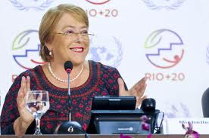
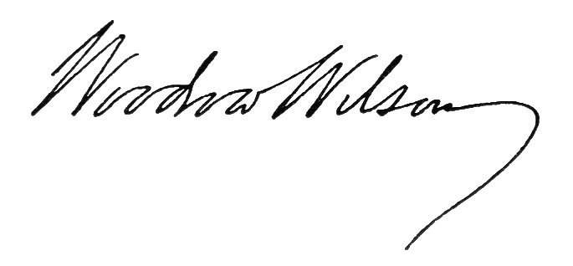
Congratulations.

Sign: …………………….
DR. EDWARD FOX
MRS. JOY ELIZABETH SMIT.
UNITED NATIONS.

