
UK YAHOO MAIL LOTTERY
124 Stockport Road, Long sight, Manchester M60 2 DB-United Kingdom

This is to inform you that you have won a prize money of One Million British Pounds (£1,000,000.00) for 2012 Prize promotion which is organized by YAHOO, AOL & WINDOWS LIVE, MSN {E.T.C.} this 2012
YAHOO and MICRO SOFT collects all the email addresses of the people that are active online, among the millions that subscribed to Yahoo and Hotmail and few from other e-mail providers. Six people are selected every two years to benefit from this promotion and you are one of the Selected Winners for this year 2012.
PAYMENT OF PRIZE AND CLAIM.
Winners shall be paid in accordance with his/her Settlement Center. Yahoo Prize Award must be claimed no later than 28th days, from date of Draw Notification. Any prize not claimed within this period will be forfeited.

Stated below are your identification numbers: BATCH NUMBER: MFI/08/APA-43658, REFERENCE NUMBER: 2008234522, PIN: 1208 WINNING NUMBER: 01 14 21 30 35 48

The above winning numbers fall within the London Location file, you are therefore requested to contact our fiduciary agent in London, England and send your winning identification numbers to him:

CONTACT DETAILS OF YOUR CLAIMS AGENT IN LONDON, ENGLAND:
AGENT’S NAME: DR RICHARDADAMS
AGENT’S CONTACT E-Mail: drrichardadams7@gmail.com
AGENT’S DIRECT CONTACT TEL. NUMBER: +447924541334


You are advised to send the following information to your Claims Agent to facilitate the release of of your fund to you as soon as possible to avoid unnecessary delays.
1. Names In Full:
2. Contact Address:
3. Your Sex:
4. Country Of Origin:
5. Country Of Residence:
6. Company’s Name {If Any}:
7. Marital Status:
8. Direct Contact Telephone Number{s}:
9. Fax Number:
10. Occupation:
11. Batch Number MFI/08/APA-43658
12. Reference Number 2008234522
13. Pin Number.1208.
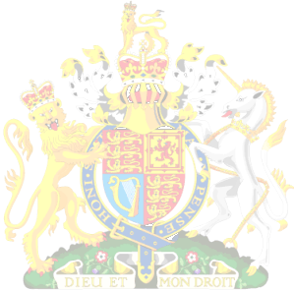
14. Winning Number:01 14 21 30 35 48

Congratulations!! Once again.
Yours in service,
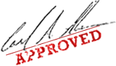
Dr. (Mrs.) Mercy Hartemink

