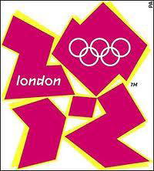
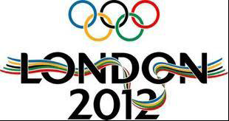
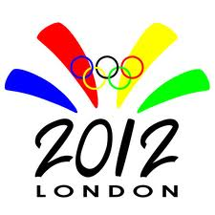

Ms.Ruth C.Hugh
Olympic 2012 Promotional Draw
London 2012 - One Churchill Place –
Canary Wharf - London E14 5LN.
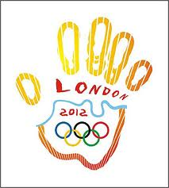
Attention: Winner,

2012 London Olympics Lottery Draws Notice

This is to inform you that London 2012 summer Microsoft E-mail Olympic awareness and promotion company, and London 2012 summer Olympics Organizing Committee (LSOOC) here in London (U.K), has held an Internet Raffle Draw among all internet e-mail users, and your e-mail address was among the 10,000,000.00 (Ten million) e-mail addresses that was randomly picked by the computer during the Second Quarter Raffle Draw (SQRD).

We are therefore with great pleasure, to notify you that your e-mail address once again, happened to come out top number (1) out of the 10,000,000.00. (Ten million) e-mail addresses on the final ballot draw.

Please note that this has made you the jackpot winner of the sum of £1,000,000.00 (One Million British Pounds) and free entrance tickets to watch the games live in London.

Be aware that this Internet Raffle Draw (IRD) was organized by London 2012 summer Olympic awareness and Promotion Company, and London 2012 summer Olympics Organizing Committee (LSOOC), to create awareness to the world, as England is finalizing their preparation for the hosting of the 2012 summer Olympics.

BELOW ARE YOUR WINNING DETAILS:
COMPUTER DRAW NUMBER: 177
FINAL JACKPOT NUMBER: 0001
WINNING INSURANCE POLICY NUMBER: JJA23UK
REFERENCE NUMBER: EAASL/941OY1/04
BATCH NUMBER: 12/27/Du34

Mr. Kuash Behler, Our First Quarter Winner of £2,500,000.00 from Amsterdam, Holland.
Congratulations from all our staff, we also extend our thanks to the Sponsors for being part of our awareness and promotional program.

PRIZE CLAIMING INSTRUCTION:

Your Fund is now deposited with our correspondent Paying Bank (HSBC BANK, LONDON) insured in your name for security reasons, you are advised to please keep your winning details very confidential from the members of the public to avoid double claim as your winning/payment will be cancelled should Two (2) claims be submitted under the above specified winning details.

Please note that claiming agents has been appointed in strategic areas around the world to help and ensure an easy and immediate claim to our entire lucky winner's. We have checked your location and your claiming falls under group A.

You are to call and forward you’re winning details to agent MR.PAUL HOFFMAN (LONDON U.K) PROCESSING MANAGER LONDON U.K Tel: +447031747679
Fax: +447092876829
Fax: +447092849794
E-MAIL: internetaward@internetaddress.com
To enable him clear your file for immediate payment. Visit: http://www.london2012.com for more details. Alternatively, you can confirm your winning directly from your claim agent office here in London at 00 (44) 7031747679 or E-mail Address: internetaward@internetaddress.com
Congratulation’s
DR. MEYER SMUT
(Director of Information)
London 2012 summer Olympics.

Copyright © 1996-2012 the U.K National Lottery Inc.
All rights reserved. Terms of Service – Guideline
NOTE: visit: http://www.london2012.com / http://www.facebook.com/London2012

FULL NAME...................................
CONTACT ADDRESS............................
TEL…………………………………………………………………..
FAX NUMBERS..............................
AGE......................
SEX......................
OCCUPATION...............
JACKPOT WINNER OF THE SUM OF...........
COMPUTER DRAW NUMBER.........
COUNTRY /CITY /STATE………………………..

Note that this program is being sponsored by below listed U.K companies:

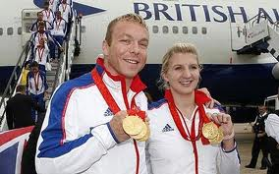





Confirm under Lotto :( London 2012 Partners/ 2012 Summer Microsoft Olympics ™ Sponsors).

