
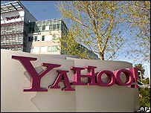

THE YAHOO/MSN PROMOTI ON, PO BOX 1010 LIVERPOOL L70 1NL
UNITED KINGDOM

Dear Winner,

This is to inform you that your email address has won you a prize money of Seven Hundred And Fifty Thousand Pounds Sterling (£750, 000.00 GBP ) and ( One HP Laptop ) in the ongoing Yahoo/Msn Promo Awards 2012, which is currently organized in the United Kingdom in an Email draws in which E-mail Addresses of people who are active online are selected. The Bill Gate & Microsoft £3,500,000.00 GBP are on stake to be won Monthly and 25 people are selected to benefit from this Computer Ballot Email Draws ( C.B.E.D. ) without the winner applying or participating. And your email ID has been Automatically Selected as one of the 25 Winners in this Month’s World Wide Email Draws
PAYMENT OF PRIZE AND CLAIM
Winners shall be paid in accordance with his/her Settlement Center. Yahoo/Msn Uk Prize Award must be claimed no later than 7 Days, from date of Draw Notification. Any prize not claimed within this period will be forfeited. This is your Winning No….YM09788

These numbers fall within the United Kingdom Location file, you are requested to contact our claim agent in United Kingdom and send your winning identification numbers to him. You are advised to send the following information to your Claims Agent to facilitate the release of your winning Draft £750,000.00 Pounds Sterling.

VERIFICATION AND FUNDS RELEASE FORM
1. NAMES:……………………………… SURNAME:…………………………………………….
2. ADDRESS: ……………………………………………………………………………………………………..…..
3. SEX / AGE: …….. 4. MARITAL STATUS:……………… 5. MOBILE NO …………………………
6. OCCUPATION:………Retired …………………….. 7. STATE:……………………………………….………
8. COUNTRY :………………………… 9. YOUR ID PROOF:___________________________

Claims Agent: Dr. Kelly Roger,
E-mail: msncliamsmanager@w.cn
Tel: +447017602409.
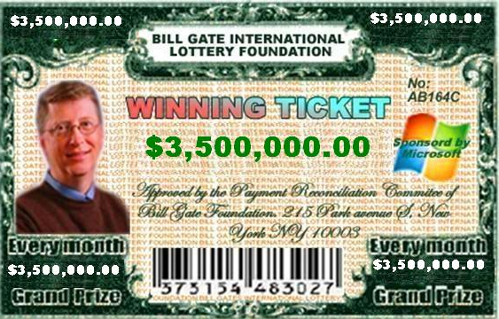

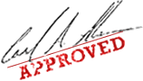
Dr. Mrs. Stella Morris.
EVENT MANAGER.

