
From The UK National Lottery
Office Address: 23-31 Huddersfield Row,
West Yorkshire United Kingdom HD2 5TXR
Tel: +44 79 24 55 14 40
Contact Agent: Mr. Adams Smith
E-mail:jedward004@gmail.com
REFERENCE NO: MSW-L/200-26937
BATCH NO: 2012MARL#L02
WINNER NO: 5
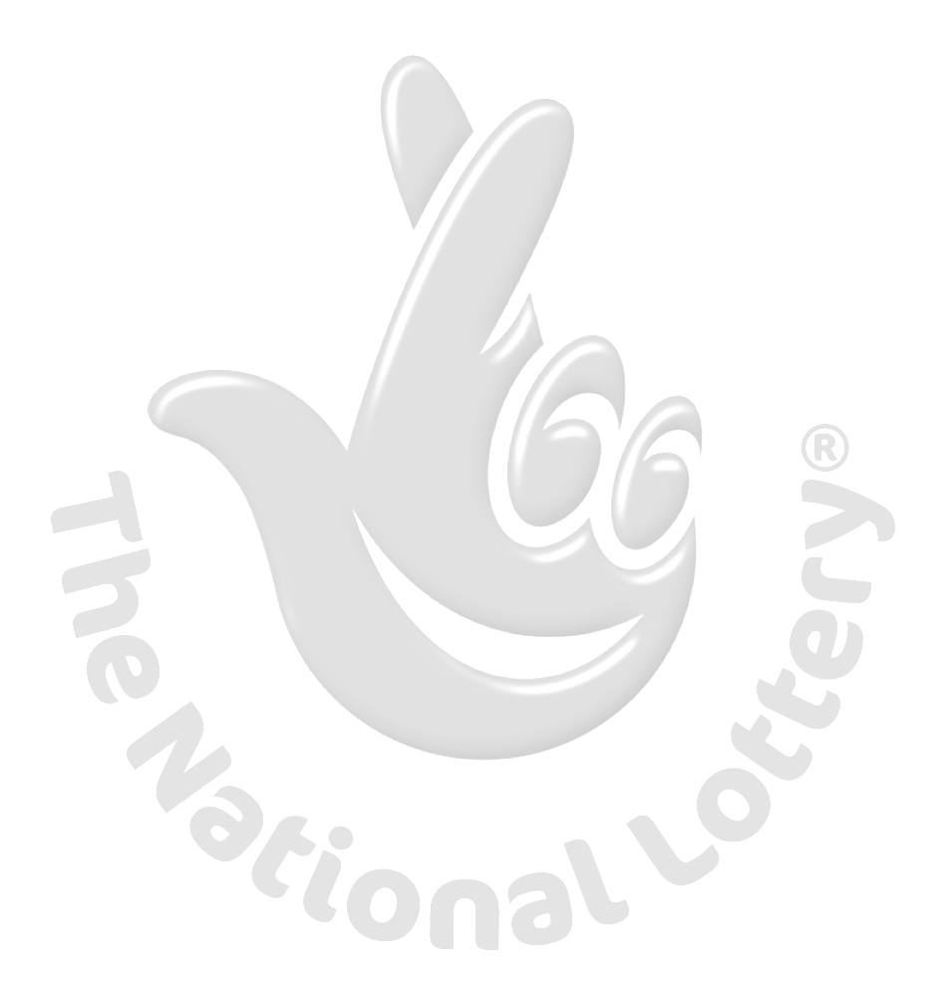
Dear Winner,
We are pleased to inform you that your emails/company address has been selected for a cash prize offer as registered member of Internet E-mail user. You have subsequently won the sum of One Million British Pounds [₤1,000,000.00] from the UK National Lottery international email promotion.

All participants were selected from worldwide websites through our Microsoft computer ballot system drawn from 21,000 names, 3,000 names from each continent (Canada, Asia, Australia, United State, Europe, Middle East, Africa and Oceania, as part of international "e-mail" promotions program, which is conducted annually for prominent ms -word users all over the world, and to encourage the use of internet and alleviate poverty worldwide
As part of our security protocol you are to quote this security code MSW/MAR/XX2012,
REFERENCE NO: MSW-L/200-26937, BATCH NO: 2012MARL#L02 to your claiming agent.
(Regarding the process to transfer your prize, kindly contact your claim agent immediately with bellow information
Provide us with your full details for your payment
Full Name Surname/First:
Telephone Number:
Reference Number:
Batch number:
Winning security code:
Nationality:
Full Address:
Age/Sex:
Endeavor to email/fax the agency your full details such as your winning information.
If you do not contact your claims (AGENT) within 72 hours of this notification, your winning could be revoked. Winners are advised to keep their winning information secret to avoid fraudulent claim (IMPORTANT) pending the transfer/claim by Winner.
Congratulations once again!!!
Regards,
Mrs. Joyce Gosselin (Announcement)
---------------------------------------------------------------------------
Mr. John Smith (PM)
Mr. Evans Cooper [Director].

