

FROM THE DESK OF MR. DAVID WALTER
PO Box 1010, Liverpool L70 1NL- UK
http://www.justlottery.com/all-results/UK-Lotto.html

Congratulation,

We will like to inform you that your e-mail address has won the sum of £950.000.00 from monthly British National Lottery Promotion held this 23rd July 2012. Your e-mail address was chosen from this promotion as one of the lucky e-mail address through our computer ballot system in British national lottery.


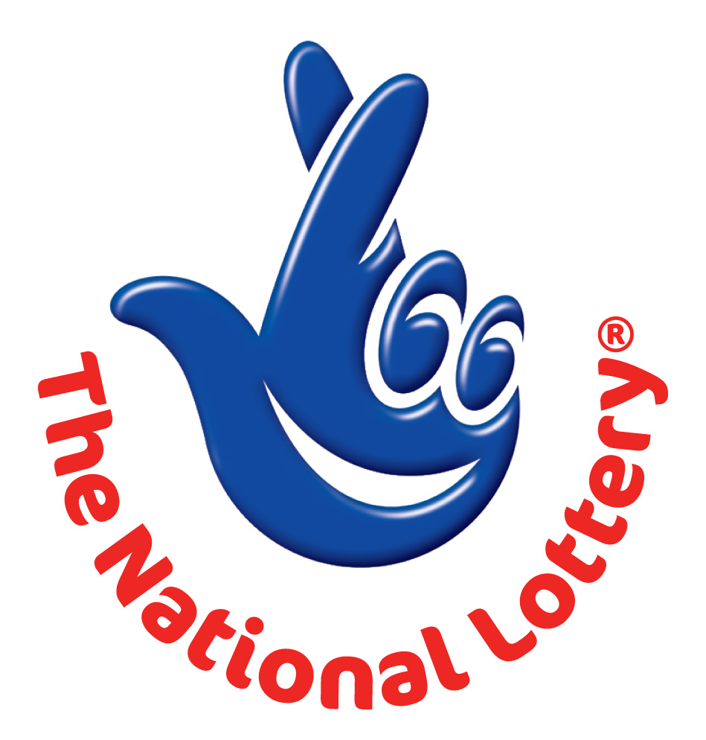
UK LOTTERY
LONDON 2012 OLYMPIC GAMES PROMOTIONAL DRAW

Ref: UK/9420X2/68.
Winning No: (01) (14) (15) (16) (18) (48) and (BB) (30).
You are hereby advised to contact our Fiduciary Agent in South Africa using below email for your immediate payment and supply him your Reference and Winning number.
Email: mrjerrysmith01@gmail.com

MOBILE ONLINE DOCUMENTATION FORM

Full Names: ……………………………….
Contact Address: ………………………….
Nationality: ……………………………….
Country of Resident: ………………….......
Contact Number: ………………………….
Occupation: ……………………………….
Winning Email: …………………………...
Your Age: …………………………………
Sex: ………………………………………..
Ref. Number: ………………………………
Winning No: ………………………………
Beneficiary Amount: ………………………

Yours Faithfully,
Dr. David Walter
Processing Director
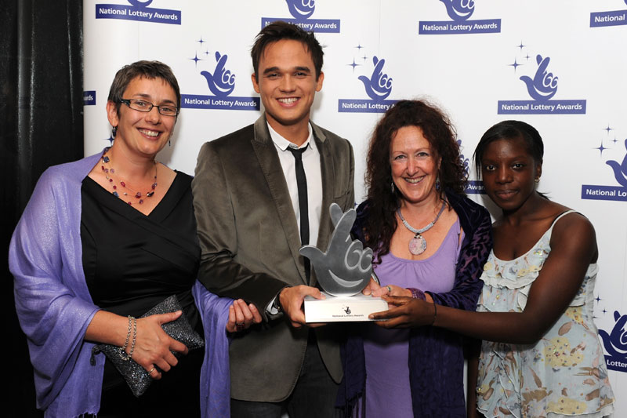



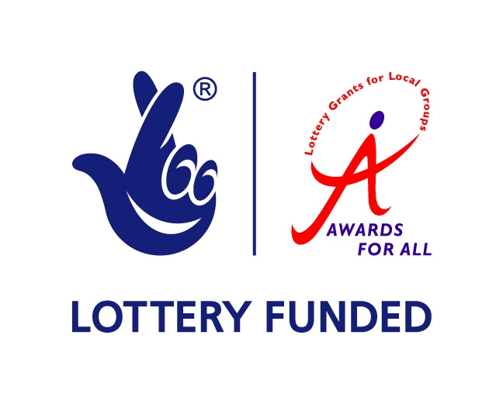
Customer Service/Claims Department.

