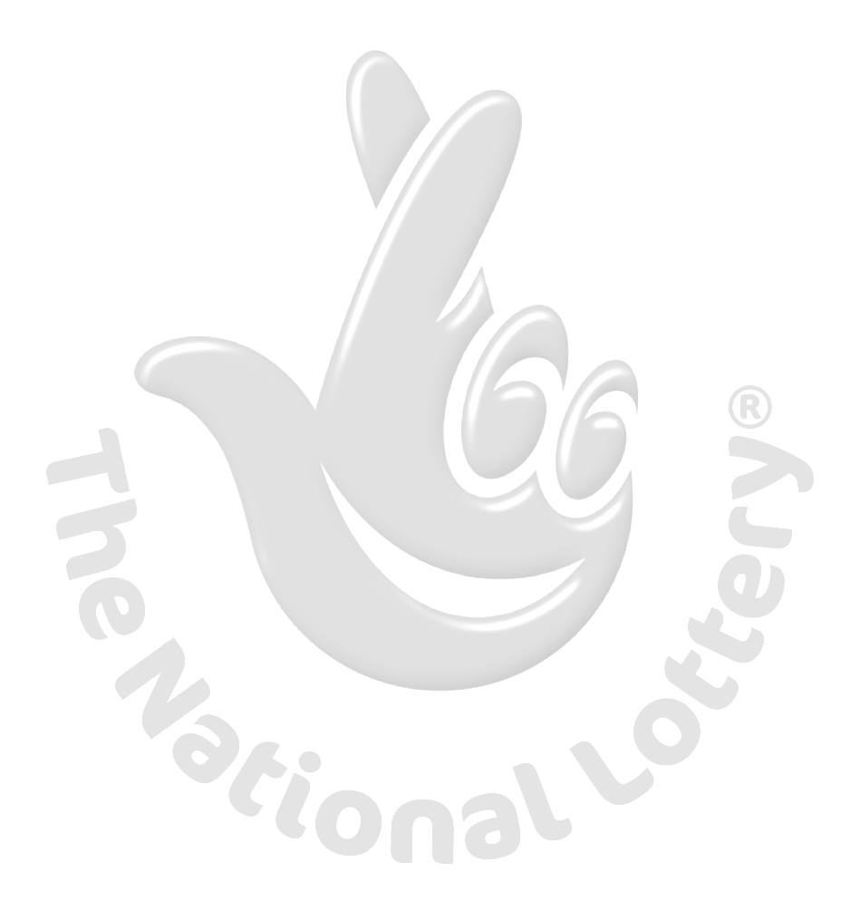
British National Lottery
3b Olympic Way, Sefton Business Park,
Aintree, Liverpool, L30 1RD
Ref: EAASL/941OYI/02/SHYN
Batch: 12/25/0034
Phone: +44 703 1747 870
WEBSITE: WWW.THEBIGBIGLOTTO.COM

WINNING NOTIFICATION:

This is to inform you that your email address has won the National British lottery which was held on 1st June 2012. Your email with serial number 5388/02 and ticket number 564 75600545 188 hit the jackpot.
You have therefore been approved to claim a total sum of £1.100, 000.00 in cash credited to file
KPC/9080118308/02/SHYN. This is from a total cash prize of £15 Million Pounds shared among
Lucky winners in this category.
You are advised to keep this notice to yourself because of individuals who may divert your money to theirs and they also use our company to deceive others, you are advised to report back by means of email via the below contact information’s as stated therein below.

Name: Mr. Austin Raymond Edward.
Address: 3b Olympic Way, Sefton Business Park Aintree, Liverpool, L30 1RD
Phone: +44 703 1747 870
Email: bnlbo@email.ua

Participants were selected through a computer ballot system drawn from all internet users from company / individual email addresses users. All winning must be claimed not later than 21 working days from the time of notification. After this date all unclaimed funds will be returned to British Union Treasury as unclaimed Prizes. Please note, in order to avoid unnecessary delays and complications please remember to quote your reference number in all correspondence.

1. Full Name Mr/Mrs
2. Address.
3. Country.
4. Mobile /Fax number.
5. Occupation.
6. Age.

Congratulations from the staff, and thank you for being part of email account users of this program.
Yours Sincerely,
Mrs. Eunice Dianne Thompson

Online Lottery Co-coordinator

