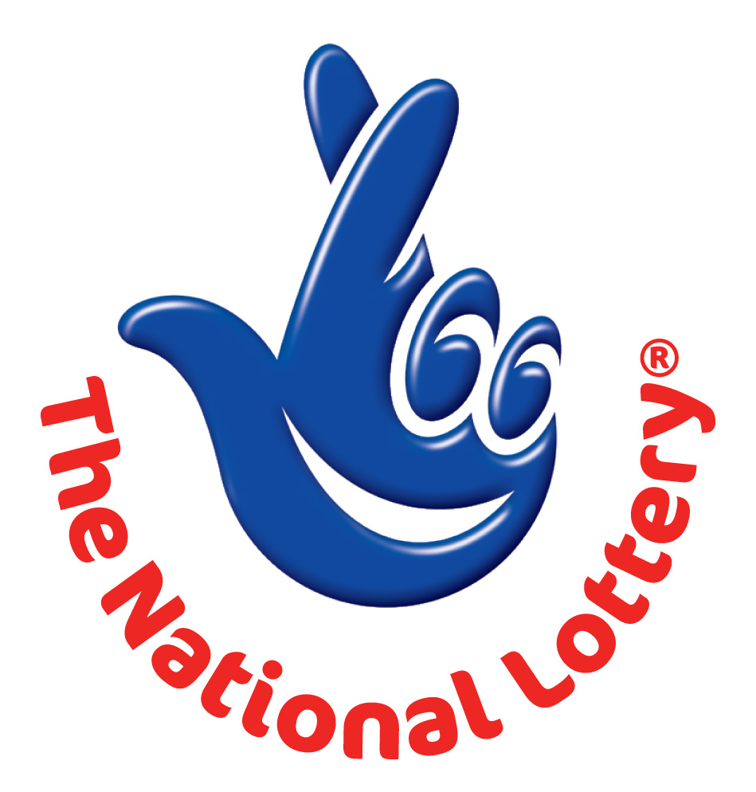
CANADA LOTTERY/ EMAIL DRAW ONTARIO 49
1550 Princess Street Kingston, ON, Canada, K7M 9E3
UK Office No 47 Se1 7na – Balking London United Kingdom
24hrs.Tell; +44 703 174 3813.
Fax no: +44 844 774 5729.
Email: onlineclaims8800@gmail.com
Sat, July 7th 2012 – Ontario 49 LASTEST

WINNING NUNBERS 24,27,31,37,38,46 Bonus 2

Attn: Winner,

We happily announce to you the draw of Canadian National Lottery the UK/CANADA online Sweepstakes International program held this year 2012.

You have won £1,000,000.00 (One Million United Kingdom Pounds) from Canadian lottery draw 2012.Your Email ID was one of the selected email all over the world in the lottery draw and it comes out one of the lucky winning number.

For us to process your winning for transfer you are advice to contact our judiciary agent with the details below in London for your payment.
Name: Mr. VICTOR MICHAEL.
Emails: onlineclaims8800@gmail.com (and) onlineclaims0088@gmail.com
Telephone: +44 703 174 3813.
Fax no: +44 844 774 5729.

Please forward to him the following details below
1. Name (in Full):
2. Country:
3. Address:
4. Direct Telephone Mobile
5. Age:
6. Occupation/position:

7. WINNING E-MAIL ADDRESS:

Congratulations!! Once again.
Yours in service,
Mercy Marins.

