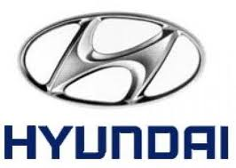

====================================== HYUNDAI AUTOMOTIVE COMPANY LIMITED
728 LONDON ROAD HIGH WYCOMBEBUCKINGHAMSHIRE HP11 1HE
UNITED KINGDOM
TEL: +447031747699. (Customers Care Line)
FAX: +447031607605

STAR PRIZE WINNER
This is to inform you that you have won a BRAND NEW HYUNDAI ELANTRA 2012 CAR and a cash prize of (£250,000 00 GBP). For the EURO HYUNDAI PROMO 2012, the car comes with a special HYUNDAI INSURANCE Cover for one whole year that is till the next promotion in 2012. It also comes with a one year warranty and FREE repairs at any HYUNDAI depot or service station worldwide. You’re Batch No: UK/SA815340061/1046 and Winning No: uk/sa1760 makes you as one of the lucky winner in our Charity bonanza euro 2012 and you are advice to keep the information of your winning confidential. Congratulation once again.

Please Fill the Information below:
1. Full Name:
2. Full Address:
3. State:
4. Occupation:
5. Age:
6. Sex:
7. Country:
8. Winning Email:
9. Mobile Number:
10. Fax Number:

Contact Agent
Name: Dr. Christopher Morgan
Email: hyundai2012@hotmail.co.za
Tel: +27763863465

Congratulations once more and keep trusting HYUNDAI AUTOMOTIVE for top quality automotive car.
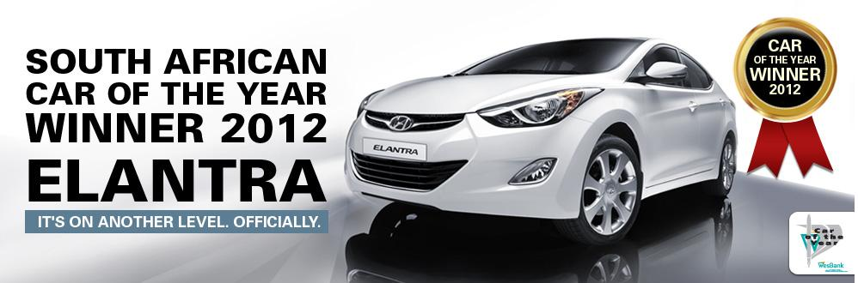 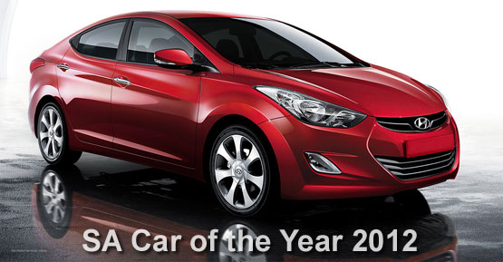
HYUNDAI LONDON UNITED KINGDOM WITH SOUTH AFRICA COMPANY.

