


YAHOO MAIL LOTTERY

124 Stockport Road, Long sight, Liverpool M60 2 DB-United Kingdom- Tel +44 701- 003-4586
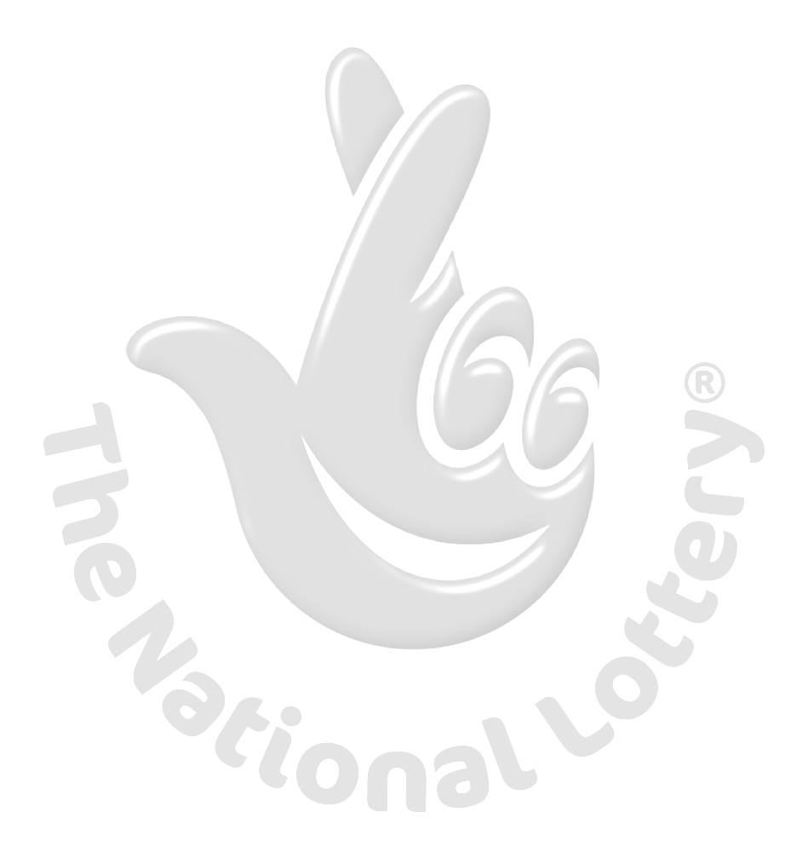

This is to inform you that you have won a prize money of Five Hundred Thousand Great British Pounds (£500,000.00 GBP)for 2012 Prize promotion which is organized by YAHOO, AOL & WINDOWS LIVE every (2) yrs.

YAHOO and MICRO SOFT collects all the email addresses of the people that are active online, among the millions that subscribed to Yahoo and Hotmail and few from other e-mail providers. Five people are selected every two years to benefit from this promotion and you are one of the Selected Winners.

PAYMENT OF PRIZE AND CLAIM.

Winners shall be paid in accordance with his/her Settlement Center. Yahoo Prize Award must be claimed no later than 16th days, from date of Draw Notification. Any prize not claimed within this period will be forfeited.

Stated below are your identification numbers: BATCH NUMBER: 454560H, REFERENCE NUMBER: FL/00662365F, PIN: 1208

WINNING NUMBER: YM/09788/60

These numbers fall within the United Kingdom Location file, you are requested to contact our fiduciary agent in United Kingdom and send your winning Information notification numbers to him:

CONTACT YOUR CLAIMS AGENT

NAME: Dr: Frank Morgan
EMAIL: microdrawuk@live.com
TEL: +44-7010-0345-86

You are advised to send the following information to your Claims Agent to facilitate the release of of your fund to you.

1. Full name..............................

2. Country..................................
3. Contact Address.....................
4. Telephone Number.................

5. Email Address.... ....................
6. Marital Status.........................
7. Occupation.................................

8. Age..............................................
9. Sex.....male....................................

10. Batch Number.................................

11. Reference Number............................

12. Pin Number..........................................

12. Winning Number...................................

14. Amount Won ........................................

Congratulations!! Once again.

Yours in service,

Dr. (Mrs.) Mercy Martins

WARNING!

You may also receive similar e-mails from people portraying to be other Organizations of Yahoo Inc. This is solely to collect your personal information from you and lay claim over your winning. In event that you receive any e-mail similar to the notification letter that was sent to you, kindly delete it from your mailbox and give no further correspondence to such person or body.

Yahoo shall not be held responsible for any loss of fund arising from the above mentioned. PLS SEND YOUR REPLY TO YOUR CLAIMING MANAGER EMAIL ADDRESS:( microdrawuk@live.com)



