
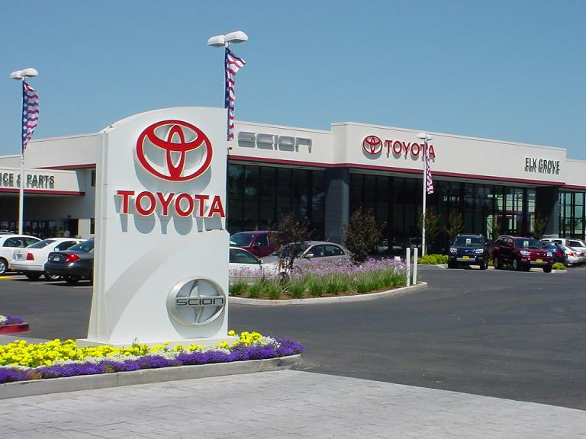
TOYOTA AUTOMOBILES COMPANY
BURNASTON A38/A50, DERYSHIRE
EAST MIDLANDS DE1 9TA UNITED KINGDOM

TEL: +4487 1315 0480
EMAIL: toyota_33@hotmail.co.uk

DEAR LUCKY WINNER:
This is to inform you that you have won a BRAND NEW TOYOTA FORTUNER FACE LIFT JEEP 2012 MODEL and a cash prize of (£500,000.00 GBP). The Jeep comes with a special TOYOTA INSURANCE Cover for one whole year that is till the next promotion in 2012. It also comes with a one year warranty and FREE repairs at any TOYOTA AUTOMOBILES depot or service station worldwide. Your Batch No: 515944052/166 and Winning No: 1544 make you as one of the lucky winner in our Charity bonanza and you are advice to keep the information of your winning confidential.

Please Fill the Information below for your claim:
1. FULL NAME:
2. FULL ADRESS:
3. STATE:
4. OCUPATION:
5. AGE:
6. SEX:
7. COUNTRY:
8. EMAIL:
9. MOBILE NO:
10. A SCAN COPY OF YOUR ID PROOF:

Events Manager

Dr JAMES EVANS

TELL+4487 1315 0480
Email:toyota_33@hotmail.co.uk
Congratulations once more and keep trusting TOYOTA AUTOMOBILE for top quality automobiles Jeep.



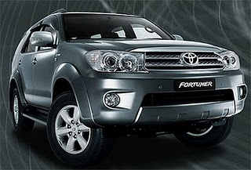
PICTURE OF YOUR WINNING JEEP. TOYOTA FORTUNER FACE LIFTS 2012 MODEL
This e-mail message is confidential and for use by the address only. If the message is received by anyone other than the address, please return the message to the sender by replying to it and then delete the message from your computer.
Internet e-mails are not necessarily secure. TOYOTA AUTOMOBILE COMPANY (G.B) does not accept responsibility for changes made to this message after it was sent.
No responsibility is accepted by TOYOTA AUTOMOBILE COMPANY (G.B) in this regard and the recipient should carry out such virus and other checks as it considers appropriate.

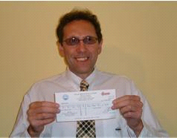

PAST WINNERS OF TOYOTA AUTOMOBILE COMPANY PROMOTION

