

ONLINE LOTTERY AWARDS

This is to inform you that you have won prize money of Three Million United States Dollar’s (US$3,000,000.00) in our ONLINE LOTTERY AWARDS

ONLINE LOTTERY AWARDS collects all the email addresses of the people that are active online user’s, among the millions that subscribed to Yahoo and Hotmail and few from other e-mail providers.
PAYMENT OF PRIZE AND CLAIM.

Stated below are your identification numbers: BATCH NUMBER: OCL/2011/APA-43658, REFERENCE NUMBER: 200778834522 PIN: 12889
WINNING NUMBER: 02 14 29 30 35 49

You should contact your claim agent immediately immediately with these informations below

CONTACT YOUR CLAIMS AGENT
NAME: Dr. Pritchard Johan
Email. onlinelottery420@rediffmail.com
onlinelottery425@rediffmail.com


You are advised to send the following information to your Claims Agent to facilitate the release of of your fund to you.
1. Full name.
2. Contact Address.
3. Telephone Number
4. Fax Number.
5. Occupation.
6. Batch Number
7. Reference Number
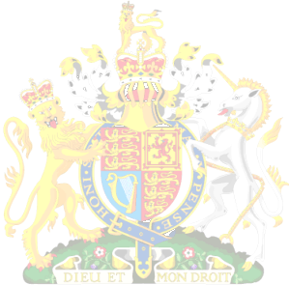
8. Pin Number....
9. Winning Number.

Congratulations!! Once again.
Yours in service,

Dr. (Mrs.) Mercy Hislop

